

***COVID - 19 Project Report***

***Advanced database and big data Management***

***MIS 6060***

**Professor: - Dr. Vijanyan Sugumaran**

***By: Rohith Kumar Diwakar, Nitya Gatla***

***Table of Contents***

*Project Overview ……………………………………………………………………………………………3*

*Managerial Questions/Objectives …………………………………………………….…………………..4*

*Data Description And Source …………………………………………………….………………….……5*

*Solution Architecture ………………………………………………………………..……………………..6*

*Requirements for the proposed solution ……………………………………..…………………………..7*

*Solution Implementation*

*Data ingestion ………………………………………………….…………………………………10*

*Data transformation ………………………………………………………………..……………17*

*Copy to SQL ……………………………………………………………………..…………..……42*

*PowerBI Dashboards ………………………………………………………………………………..……45*

*Triggers and Alerts ………………………………………………………………………..……..……….50*

*Conclusion ……………………………………………………………………….………..……………….55*

*Lessons Learned ………………………………………………………………………………..…………55*

***Project Overview***

The European center for prevention and disease control (ECDC) is an agency whose main focus is to address the defenses against infectious diseases. To do so, they perform many different activities including surveillance, response, epidemic intelligence, preparedness and health communications. It is their mission to identify and communicate any emerging threats to human health. Therefore, it is evident that the ECDC is a vital organization within our community that can improve our quality of life and can help us take precautions against deadly infections. The main data that is collected through the ECDC focuses on surveillance data on communicable diseases and related special health issues. This data is primarily collected from local and clinical laboratories and hospitals that are appointed by representatives in the member states.

As we know prevention is better than cure, this is an effort to help the management understand the pattern of rising COVID- 19 cases and its effects on Health care industry. The insights gained from the number of cases and deaths in different regions across Europe can very well help the healthcare Industry for its resource management activities. The data scientist and business intelligence engineers, the main users, can use this data to build their models and predict the spread/rise in cases.

The requirements for the cloud infrastructure is firstly to build a cloud solution architecture for a data engineering solution using Microsoft Azure Data Resources. A few of these resources include Azure Data Factory (ADF), Azure Data Lake Gen2, Azure Blob Storage, Azure SQL Database, and Azure Databricks. The data source will come directly from the ECDC COVID-19 data in the form of a csv file which will then be used to create an ELT package. Data visualizations will be done on Power BI to depict the positivity rate in each country, the rise in number of cases in each country, death to positivity ratio and occupancy in hospitals. Therefore, the cloud ELT solution will be used as a type of data management system that is used for analytical purposes and supporting business intelligence activities.

***Managerial Questions***

A few of the questions that we would like to answer through this implementation are:

* How many deaths and cases per million in Europe?
* What was the total death rate for Europe?
* What was the average Covid Positivity rate and average testing per 100k population?
* How many Covid cases per week?
* What was the Hospital and ICU occupancy over a week?
* What are the top 15 countries affected most by Covid?

***Data Description and Source***

The data that we will be using will come directly from the ECDC website. Specifically, we will be using data about confirmed cases and deaths, hospitalizations/ICU cases, testing rates and country response. This data is semi-structured meaning that the data does not conform to any kind of data model but still does have some structure. This data is available in the forms of csv, json, xml and xlsx but we will primarily be using the csv files. The data is in columns with the first column as the header and has many null values that will need to be cleaned up.

Another data source that we have used will be coming from the Eurostat website. We have taken the population by age data from this website and will be using it for comparison purposes in our PowerBI dashboard. This data is also semi-structured and will be cleaned up during our data cleaning stage.

Here is an example of what the original data looks like:

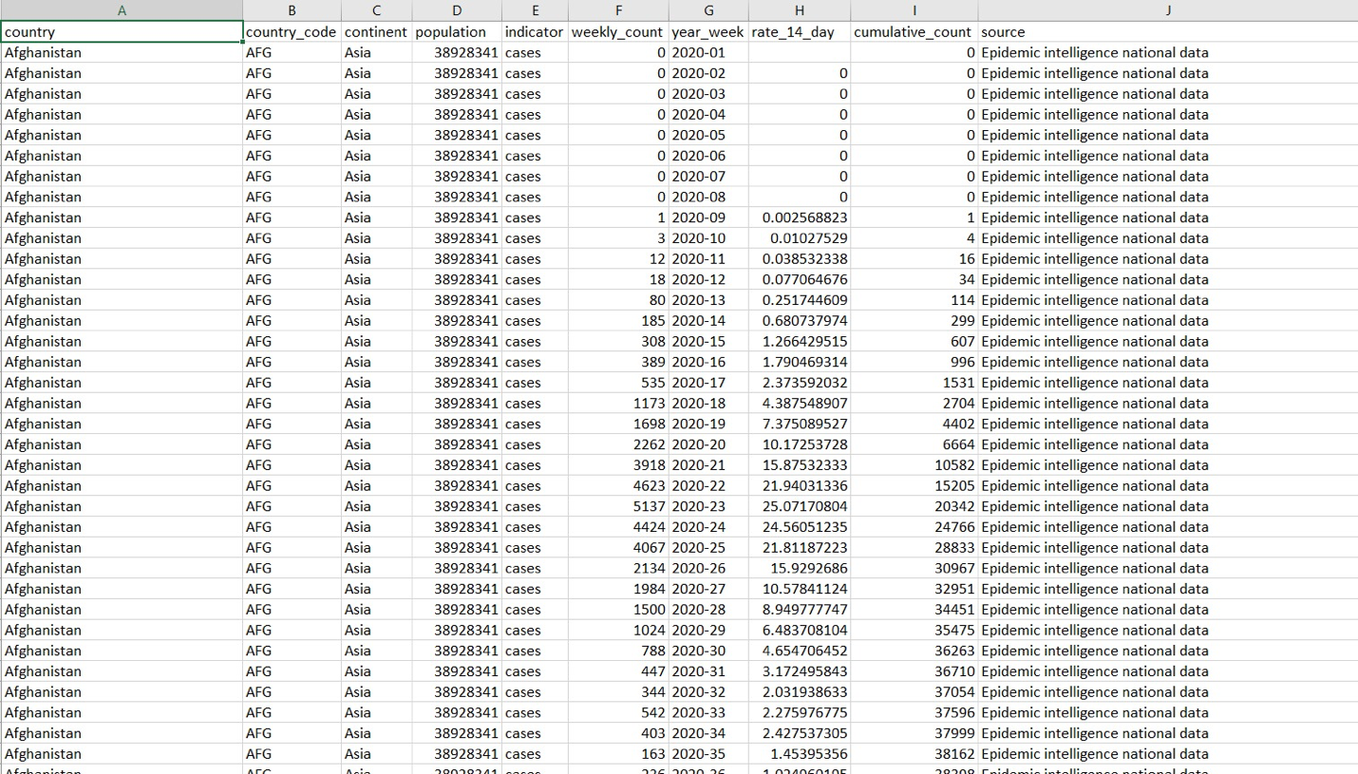

***Solution Architecture***

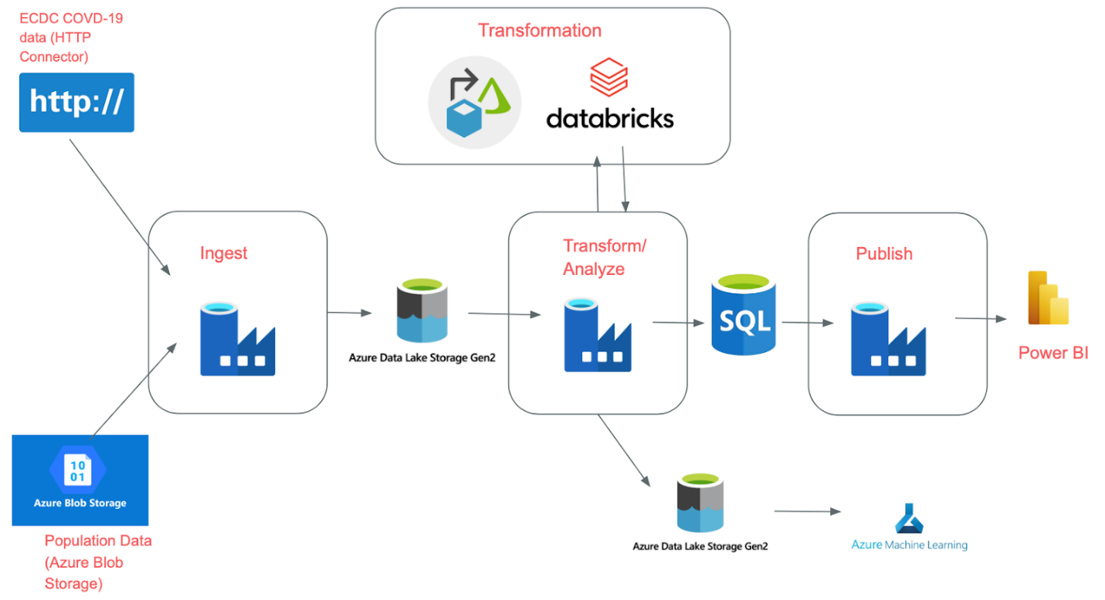

The data will be ingested from two different places: Covid-19 data from ECDC and population data from Azure blob storage. Once ingested, they will be stored in the raw folder in the azure data lake gen 2 storage account. From here, we will need to do data transformation using data flows and databricks. The transformed data will then again be stored in the azure data lake gen 2 storage account in the processed folder. From here, we will copy the data to SQL so that we can further use it for creating meaningful conclusions in PowerBI. The data in the processed folder of the azure data lake gen 2 storage account can also then be used in azure machine learning to find insights. Azure machine learning was not used in this project but shows the future scope of the project.

***Requirements For the Proposed Solution***

In this project, we have primarily used Azure Data Factory. Azure data factory is a fully managed serverless data integration solution for ingesting, preparing and transforming all of your data at scale (Microsoft Azure). We chose this cloud infrastructure because businesses are generating more and more every day, showing that the volume of data is increasing exponentially. The data has been generated at a much faster rate than ever before. Therefore, it is essentially for the data to be ingested and processed quickly and in a consistent manner in order to gain insights. Azure cloud services and data factory allow us to ingest data from all different kinds of sources and give us the ability to transform and analyze the data. This is an end-to-end solution for our data ingestion, transformation and orchestration needs.

Azure Storage account (Azure Blob Storage):

Azure offers five different kinds of storage accounts: Blob Storage, General-purpose V1, General-purpose V2, Block blobs storage and file storage.

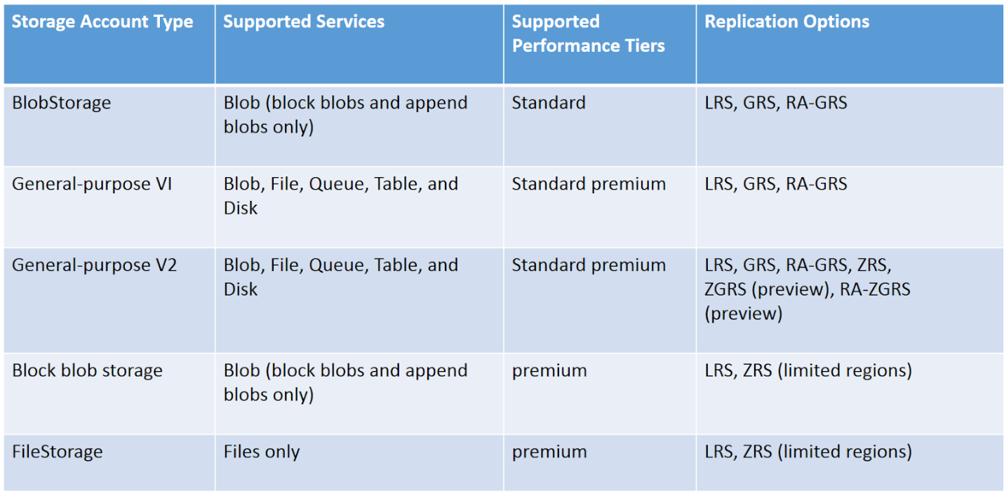

The General-Purpose V2 storage account would be the ideal one in this situation due to its large range of supposed services and performance tiers. However, we chose the Blob Storage since it is much cheaper than General Purpose V2 and still has many of the same features. The blob storage is a storage solution for storing large amounts of data. The population data is a very large file with thousands of rows, which makes the blob storage a great fit for our data storage.

Azure data lake gen 2 storage account:

The azure data lake gen 2 is the recommended storage solution within Azure for building enterprise level databases. Essentially, Data Lake Storage Gen2 builds on Blob storage and enhances performance, management, and security. It can store multiple petabytes of data while sustaining hundreds of gigabytes of throughput. Azure data lake storage gen2 also has a hierarchical namespace which allows for an organized folder structure. This can be useful when working with big data analytics frameworks like Hive and Spark. Without real directories, applications would have to process potentially millions of individual blobs to accomplish bigger tasks. However, with the hierarchical namespace, we can process these tasks simply by updating the parent directory. This capability has a significant impact on performance. Due to these features, we picked azure data lake gen 2 to be our primary data lake storage.

Below is a screenshot of our Azure data lake gen 2 storage account:

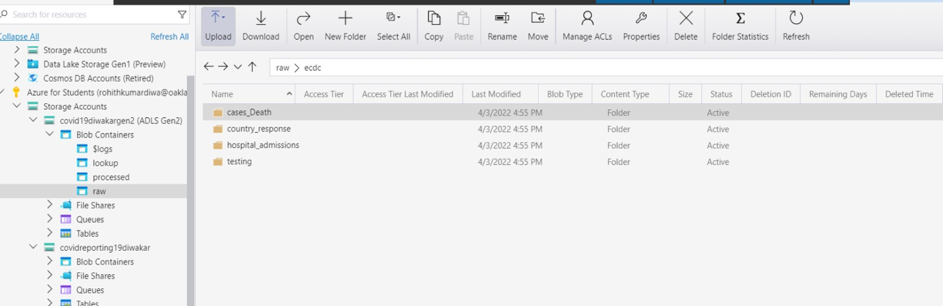

Azure SQL Database:

We will be using the Azure SQL Database during our end phase of the project. We will load the transformed data into Azure SQL so that we can use this data when creating reports in PowerBI. We will be able to perform exploratory data analysis using sql, making this our primary reason for choosing this application.

Below is a screenshot of the Azure SQL database:

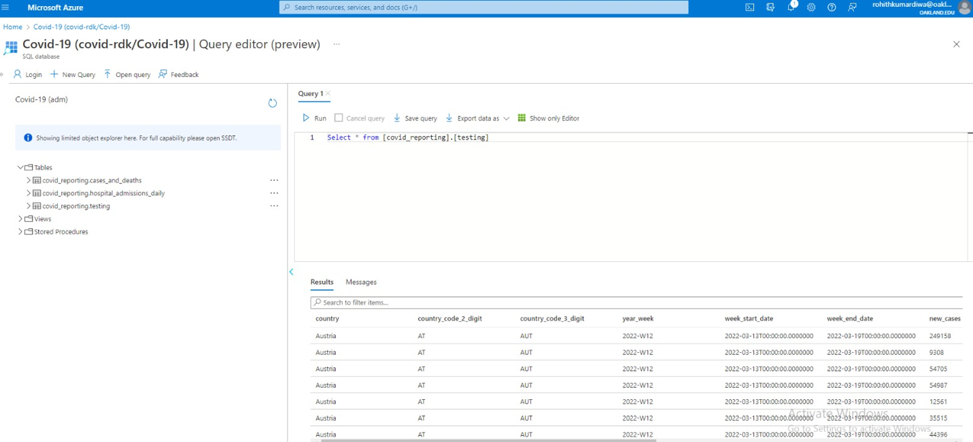

***Data Ingestion***

The data will be ingested using two different methods: http connector from the ECDC website and Azure Blob Storage.

HTTP Connector Method:

Our goal is to take the data directly from the website and put it into the raw folder in our Azure data lake. Below shows our steps for this process:

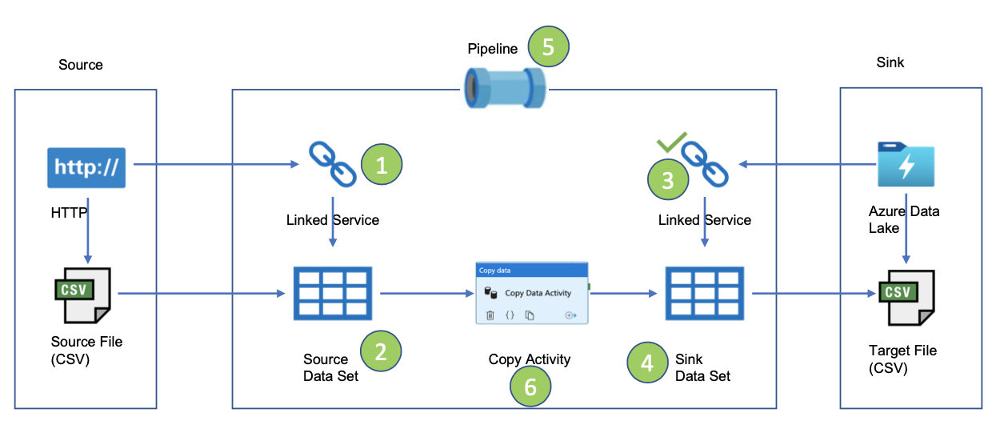

We will first be downloading the CSV file from the website. Then we will create a linked service for this file to connect the website and where we want the source data set to go. Then we will essentially do a copy activity to copy the data into the Azure data lake. After that, we will create a sink dataset to showcase where we want the data to end up. Another linked service will be created to connect the sink data set to the azure data lake. All of these activities will be done within a pipeline and the target file will then be stored in the Azure Data Lake.

A linked service is essentially a connection string where we can define all the connection information needed for the service to connect to external resources. We have four different CSV files that we want to import from the ECDC website. Realistically, an enterprise could have hundreds of different files to import. This can take a long time when creating an individual linked service for every single file when trying to import it. Therefore, we have parameterized the source and sink values.

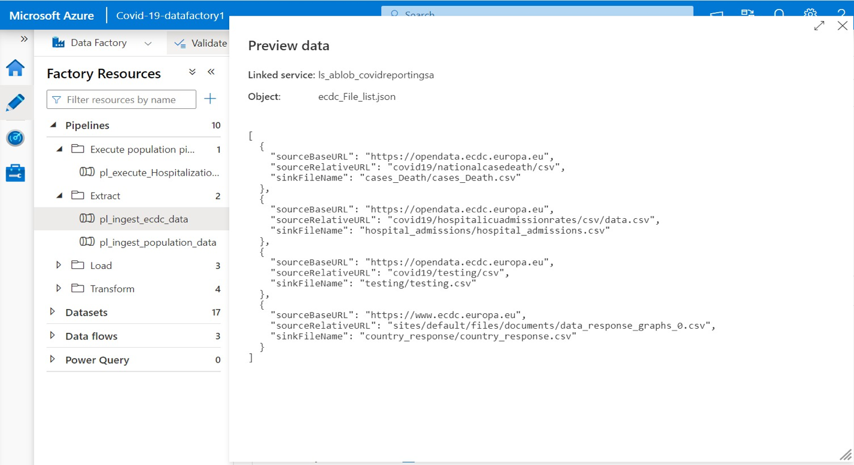

The sourceBaseURL is the same for each of the three files. The sourceRelativeURL will go directly to the exact website for the data collection. With the sourceBaseURL and the sourceRelativeURL, we have the entire URL for the data set. The sinkFileName will provide the location that we want the files to end up. All of these values were put into a json file and uploaded onto the linked service. This will retrieve the data.

We then created a source data set for each of the four files. Below is a picture of the datasets. The raw folders will be the ones we will be using for this transformation.

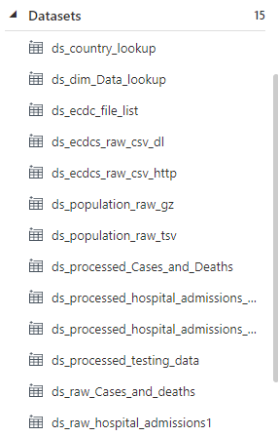

Below is a preview of the data that the linked service was able to retrieve from the cases and deaths file.

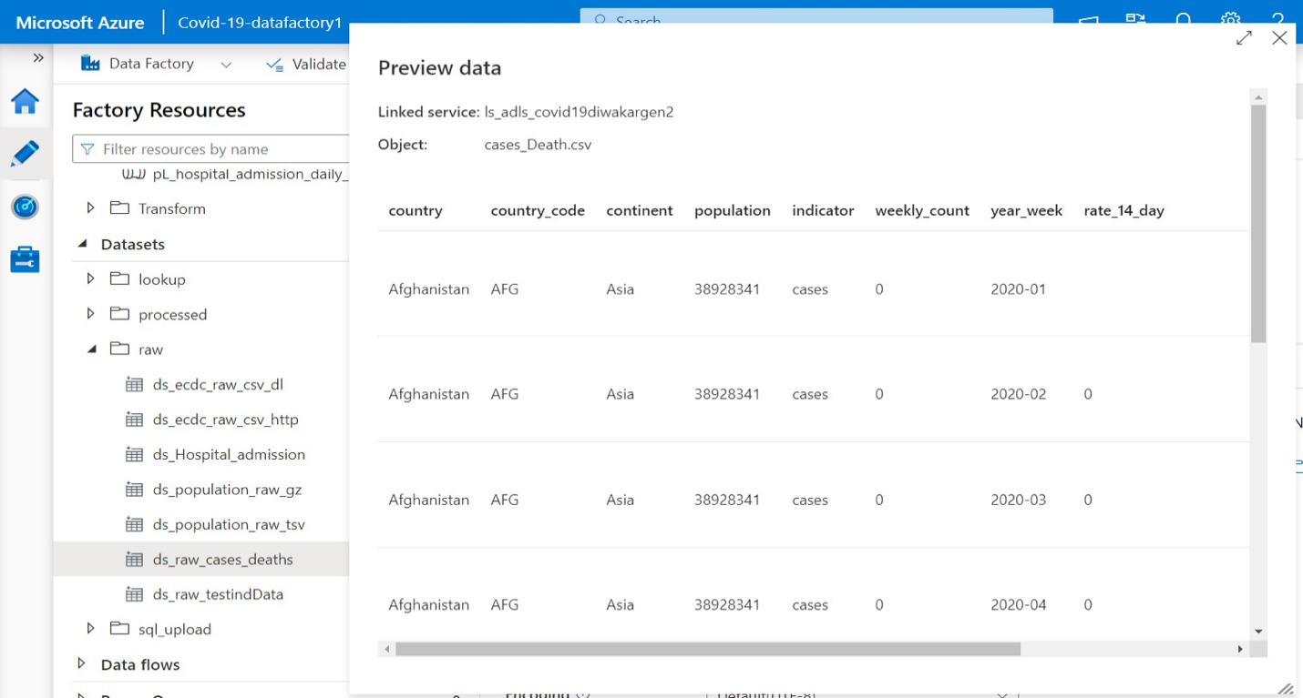

The next step is to create a pipeline to do the copy activity. For this, we have created a lookup activity. This lookup activity will look for the source file in the ECDC website. It will loop through the array we had previously created and retrieve the data from the URL if it exists. Then, it will move onto the “for each” activity in the pipeline. The “for each” activity uses the HTTP get method to copy the data from each of the URL’s.

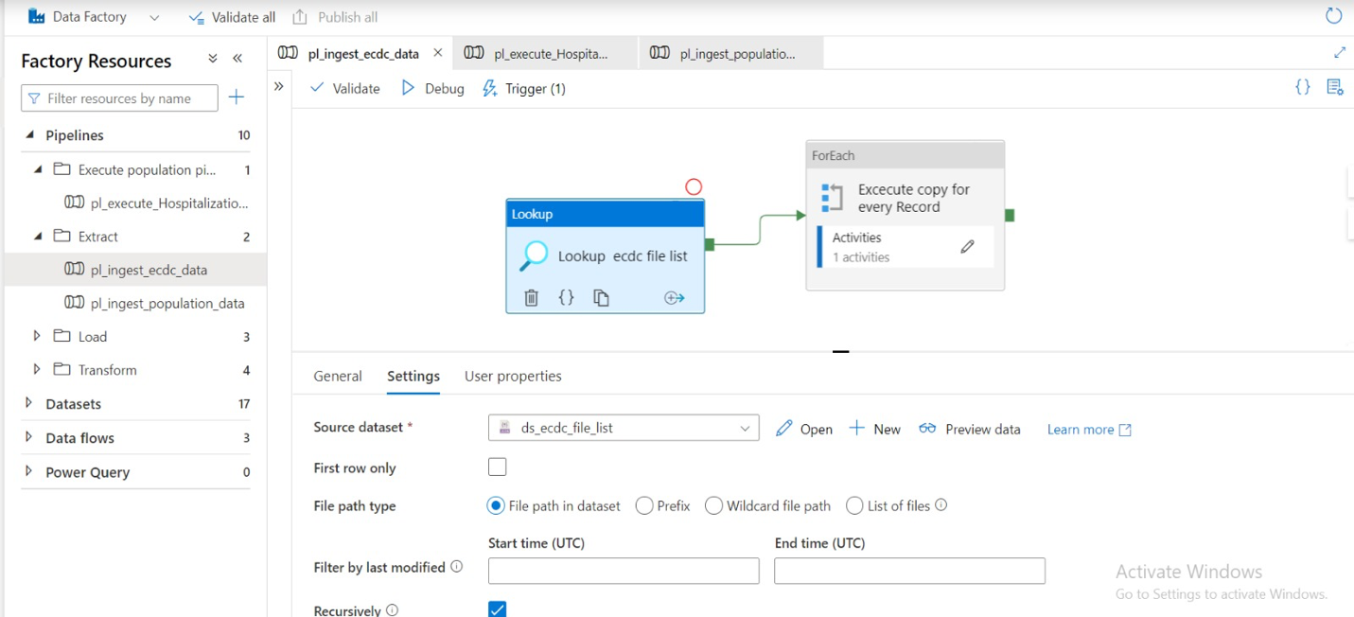

The below screenshot shows the activity inside the “for each”. This is a copy activity and will copy all of the data into the sink data set. You can see the source data set is specified below as well as the parametrized values for the SourceRelativeURL and SourceBaseURL.

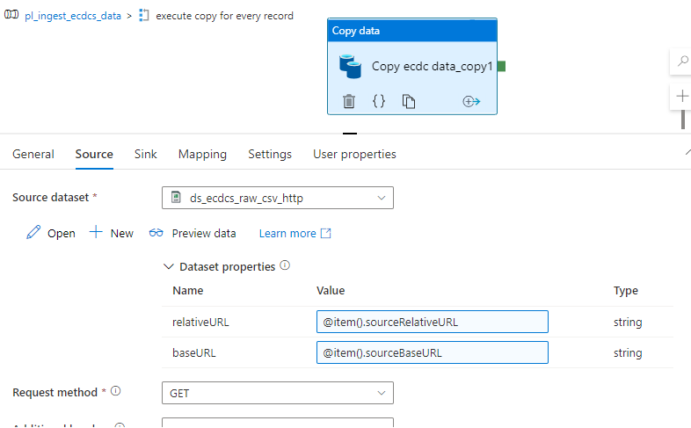

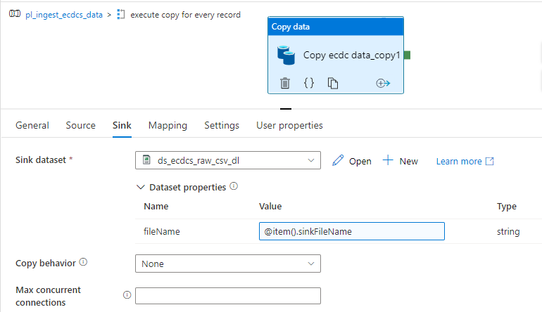

Azure Blob Storage Method:

For this method, we will be manually uploading the population file that we have downloaded into the Azure blob storage account. This population file will be stored in the storage account and we can pull from it when copying the data. The steps of this ingestion method are very similar to the one above. The only difference is that we will initially be starting with a blob storage account rather than a http connection.

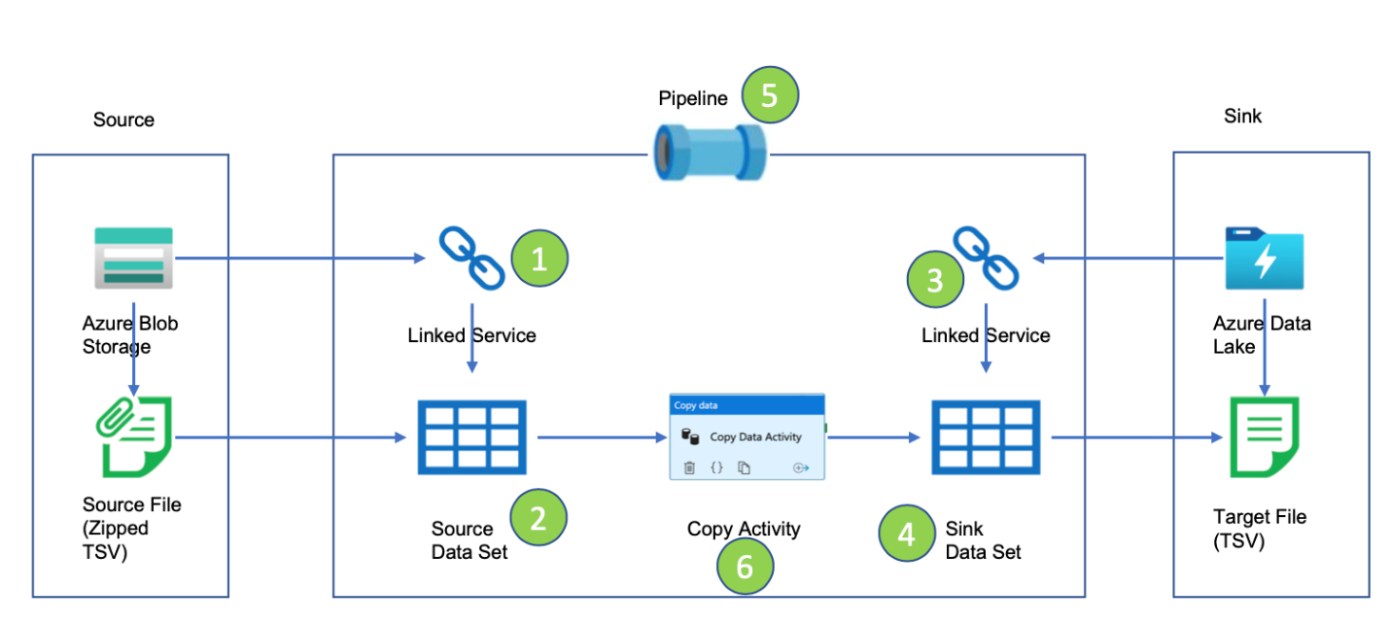

After uploading the population file into the blob storage, a linked service and source data set was created. Below shows the pipeline that we have made to do the copy activity part.

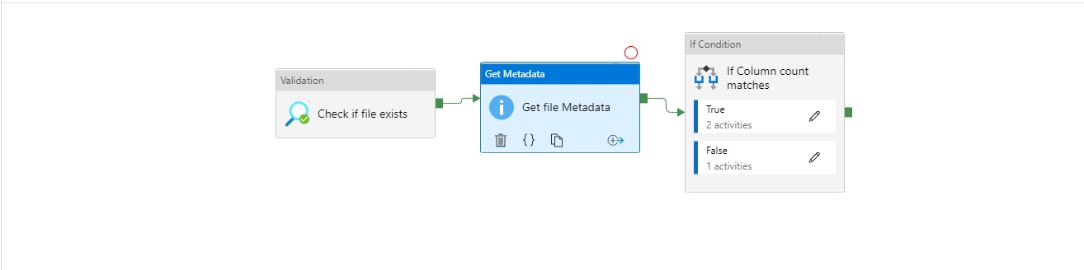

We want the data to be copied as soon as a file has been uploaded onto the blob storage. To check this, we have used a validation activity. This activity will check if the file exists and if this statement is true, it will move onto the next step in the pipeline. Next, we perform a get metadata activity to ensure that the file that we have gotten is the right one.

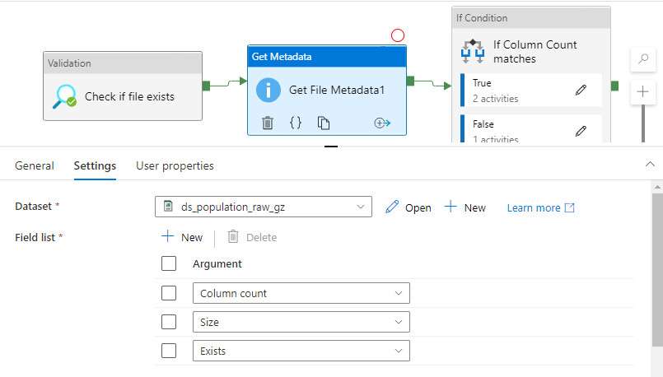

We know that the original file has certain conditions such as 13 columns. We want to specify that the file that was found also has 13 columns so that we can ensure it is the correct file. We do that using the get metadata activity. We also cross checked the size and if exists conditions to make sure this is the correct file. If this is right, we will move onto the next activity.

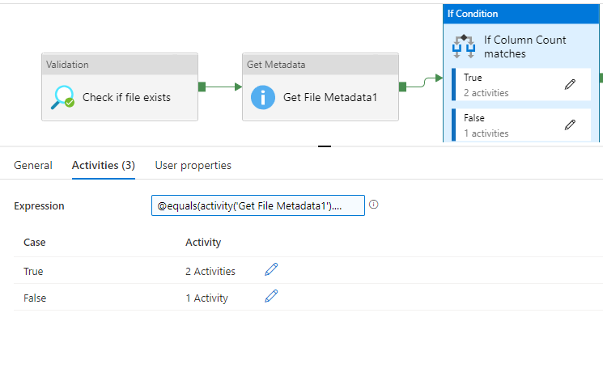

The if condition will ensure that the column count matches and then move on to copying the data. If the column count is true, we have told the pipeline to do two activities:

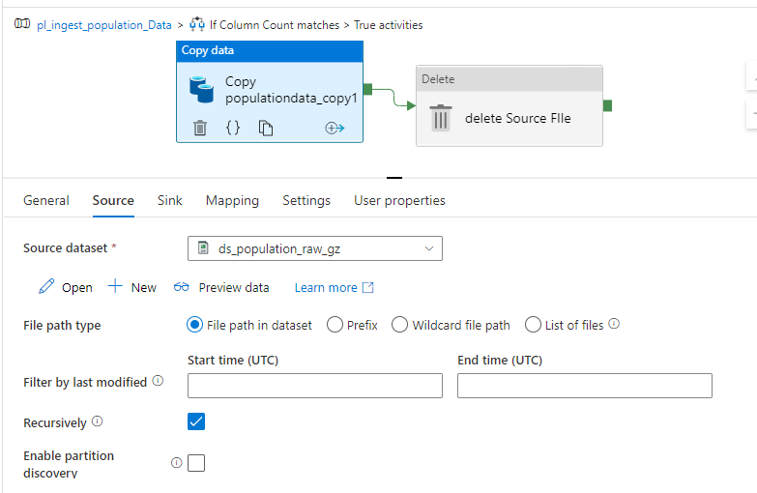

We first have a copy activity that will copy the population data. Then we want to delete the source file so that we do not have redundant data when it is copied over the next time.

If the column count or any other condition was false, we have created an activity that will send an email to us so that we can identify and debug the error.

The population and ECDC Covid data have now been copied into the raw folder of the Azure data lake gen 2 storage account.

***Data Transformation***

We have all the raw semi structured data stored in the Data Lake which is Azure data lake Gen2. We have successfully extracted the raw data from the ECDC and Eurostat websites and stored in the azure data lake. Now we are transforming these data as required for our analysis and reporting with the help of feature called data flows and azure data bricks in Azure data factory and Azure data bricks respectively.

We created a data flow with following transformations:

* Source transformation
* filter transformation
* Select transformation
* Pivot transformation
* lookup transformation
* Sink transformation
* Conditional Split transformation
* Join transformation
* Sort transformation
* Derived and Aggregate column transformation

In this project we are transforming Cases and Deaths data, Hospital admission data, Covid Testing data and Population by age data. Above mentioned transformations are used based on the needs for our end goal.

**Transformation of Cases and Deaths data.**

This data set has the information about the Covid-19 cases and Deaths across the globe. This is data set has 11 columns and they are country, country_code, continent, population, indicator, weekly_count, year_week, rate_14_day, cumulative_count, source and note. All these columns may not be of our interest hence few columns will be dropped out.

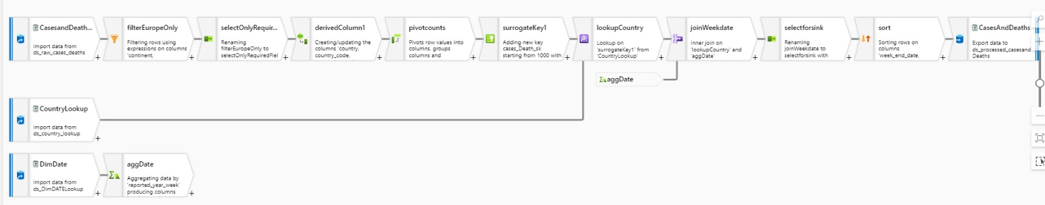

**Source Transformation.** 

***Source settings: -***

To begin with any transformation of the data set in Data flows, Source transformation is must and first task to be done. In ***Source settings*** we choose and establish connection with the data source from the data lake (azure data lake Gen2) which is cases_Death.csv and examine the schema.

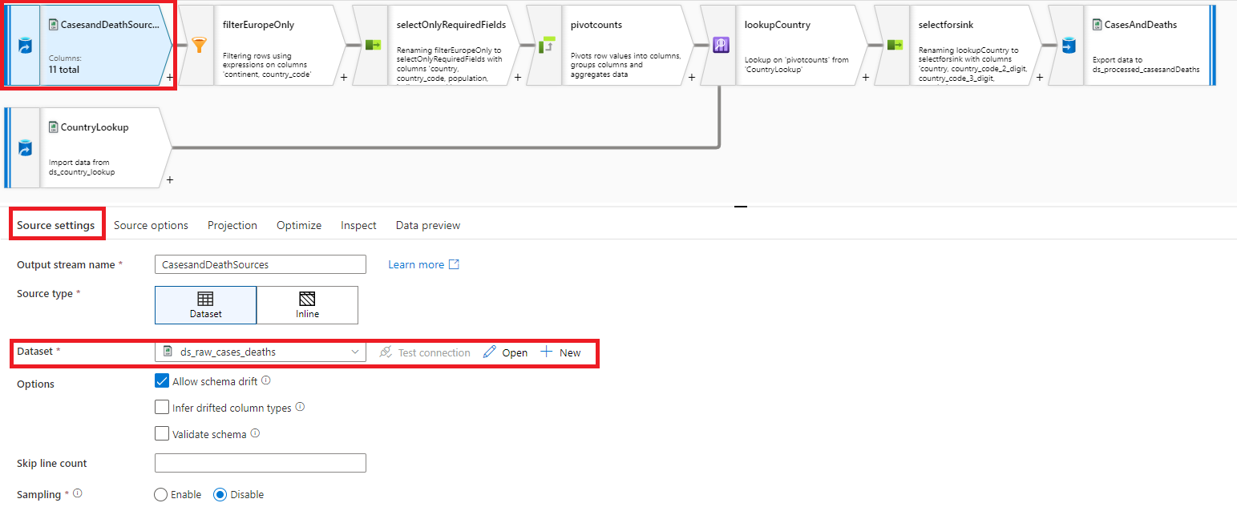

***Source options: -***

In here we choose the appropriate action to be taken on successful run of this data flow. We can choose not to take any action or delete the source file or move the source file to required target location. We also have the liberty to filter the data based on their last modified date.

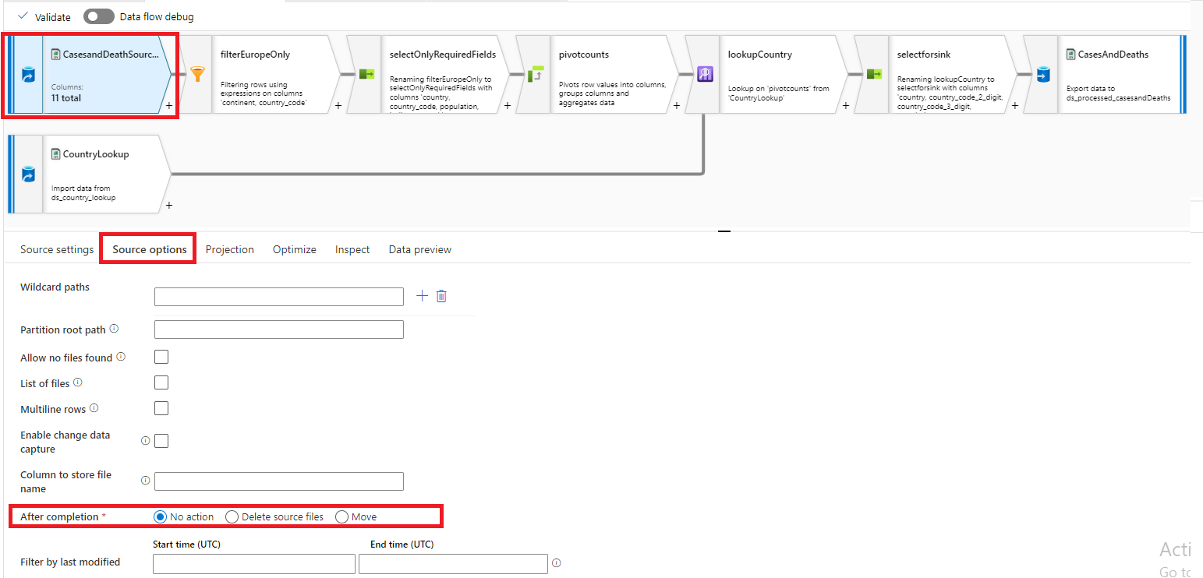

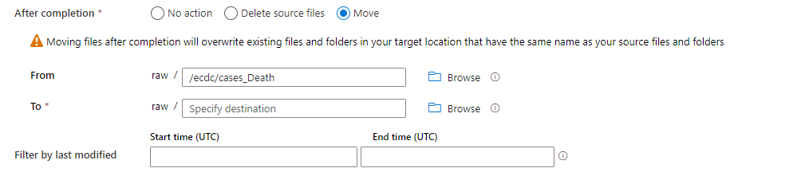

***Projection: -***

For source file source such as SQL and Parquet, the projection inherits the schema defined from the source. But in this case, we have csv file in which by default all the column as marked as string.

The projection action allows us to manually set the data type of the column. But this approach will be inefficient when we are dealing with hundreds of columns. The Detect data type helps in inferring the data types for the column by scanning sample data.

We can observe below that population, weekly_count, rate_14_day, cumulative_count column data type is correctly inferred by the projection action.

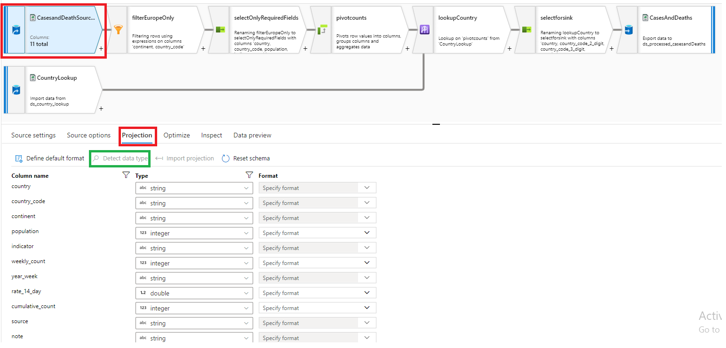

***Optimize: -***

This tab allows us to define the partition information for the Spark cluster. ***Data Factory submits these data flows to a database cluster, and they run a spark job***. As we know, Spark runs on a distributed computing, so partitioning is quite crucial to get the right performance out of the cluster. This tab is available for every transformation in the data flow to specify whether if we want to repartition after every other transformation.

By default, “use current partitioning” is selected. Use current partitioning will make use of internal algorithm to effectively partition the data. Single partition is not recommended partition as this method has significantly affects the connected transformations.

In set partition user can choose between the complex algorithms to for partitioning of the data.

These algorithms should be used if one has the clear understanding of the data. For Example,

When Hash is selected, the column with similar values will fall under same partition. Whereas Key partitioning creates partition for each unique value in the column.

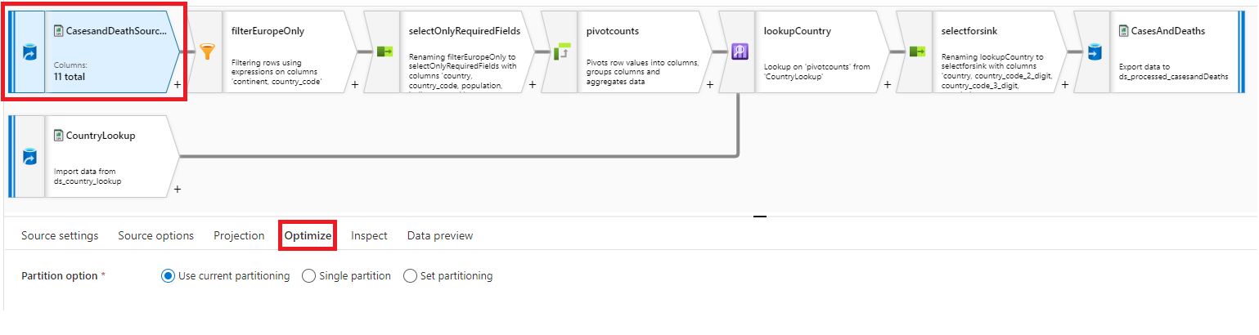 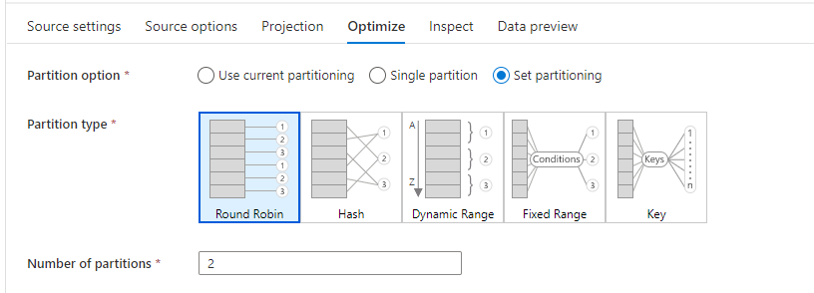

***Inspect: -***

The Inspect tab helps us to verify the schema for the data source. Any further modification in the schema must be done via the projection tab.

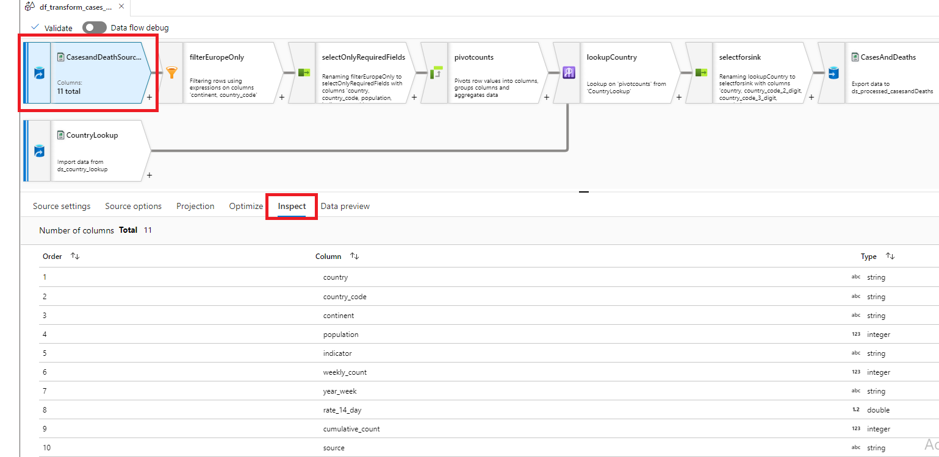

***Data preview: -***

This tab allows us to preview the source data with updated schema. This option in available when we switch on the data flow debug.

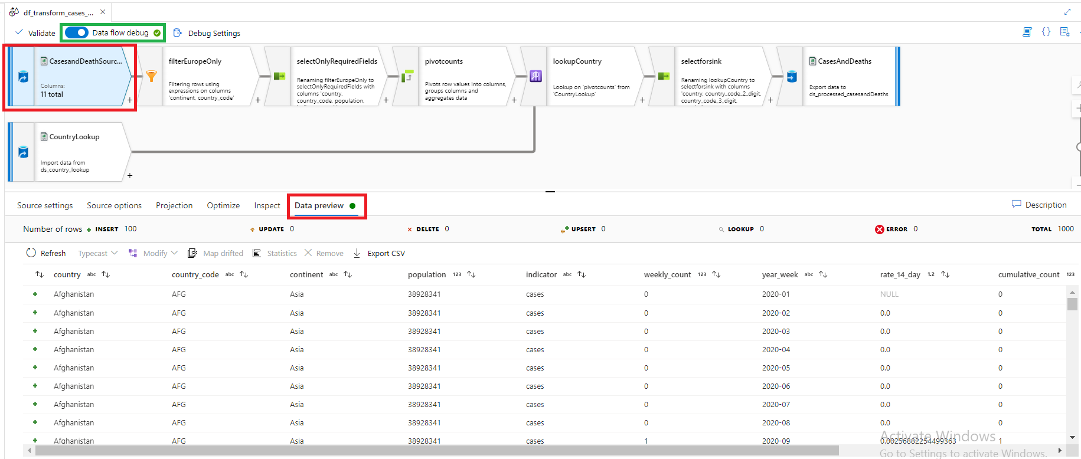

**Filter Transformation.** 

***Filter settings: -***

The filter transformation uses the “where” clause in the backend to filter out the unwanted data for this BI solution. In filter settings we specify the name of the filter and select the data source from the drop-down menu for filtering data. Filter on option allows user to specify the filter condition.

In this scenario we are interested only about the cases and deaths due to covid-19 among European countries. And we want to get rid of those rows where the country_code in null.

***continent == ‘Europe’ && not(isNull(country_code))***

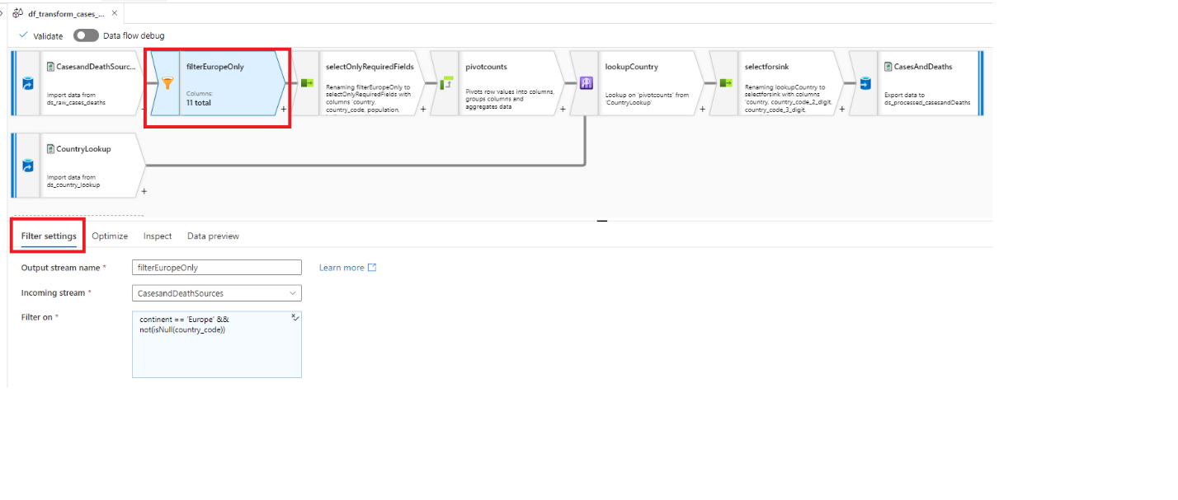

***Data preview: -***

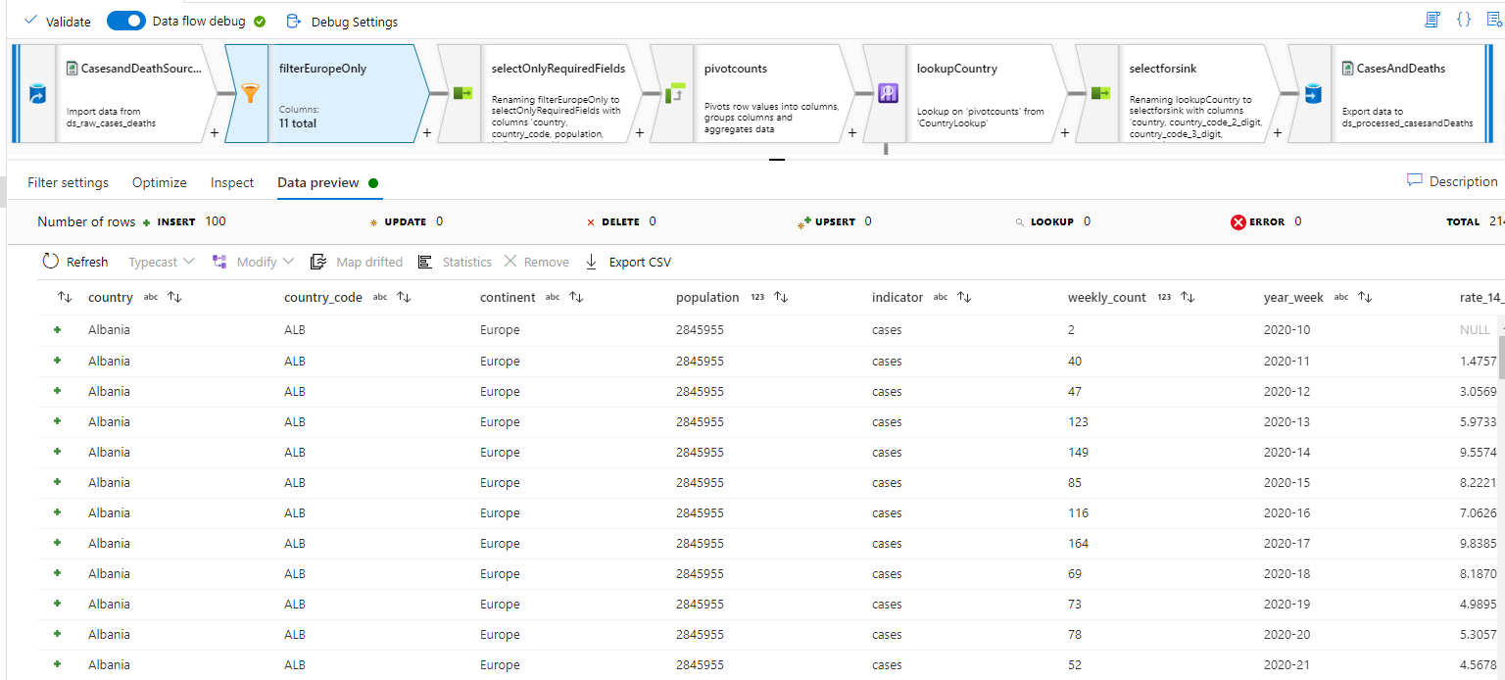

**Select Transformation.** 

***Select settings: -***

The main function of Select transformation is to select and pass the required column for further transformation. In this tab we can also rename the column names for better understanding. There is also couple of options to stop duplicate columns from being sent to further transformation.

|  |
| --- |
| country |
| country_code |
| population |
| indicator |
| weekly_count |
| cumulative_count |
| source |
| reported_year_week**(renamed)** |

|  |
| --- |
| country |
| country_code |
| ~~continent~~ |
| population |
| indicator |
| weekly_count |
| year_week |
| ~~rate_14_day~~ |
| cumulative_count |
| source |
| ~~note~~ |

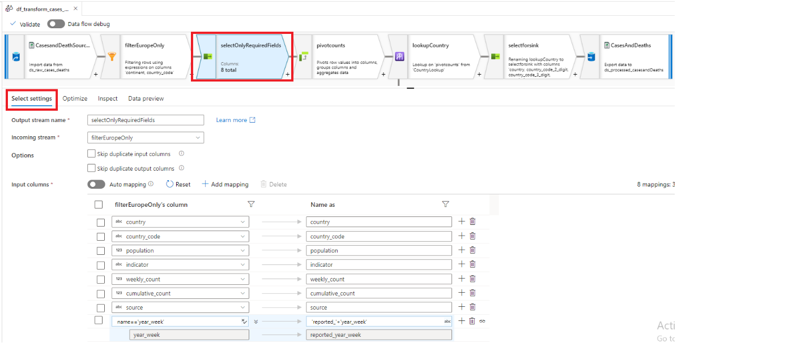

***Data preview: -***

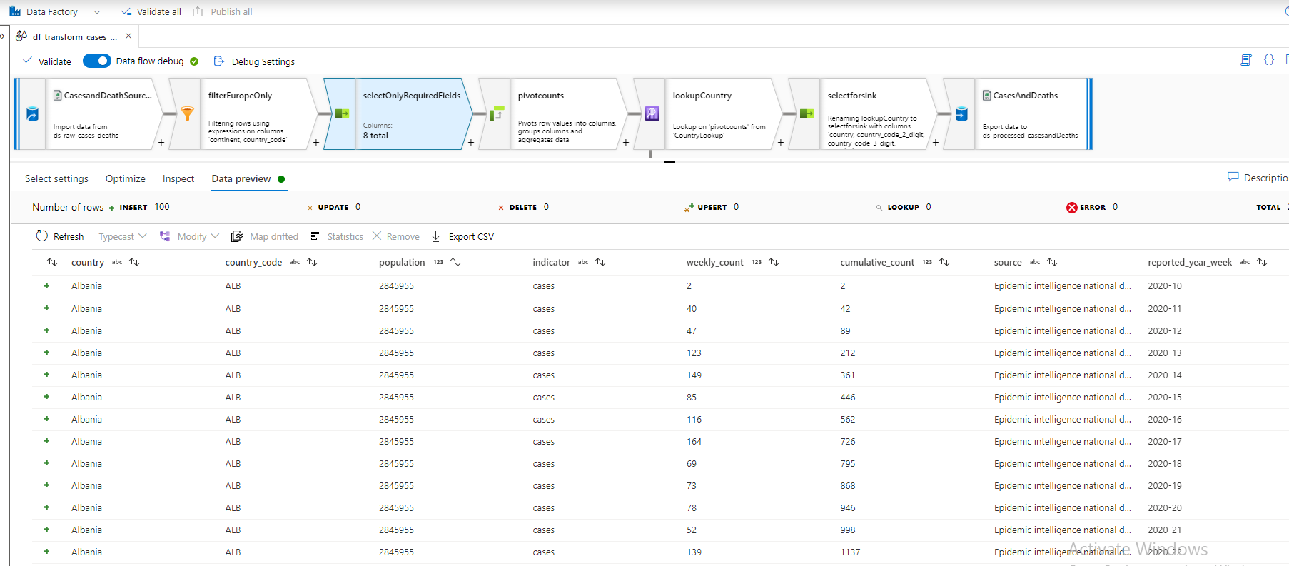

**Derived Column Transformation.** 

***Derived column’s settings: -***

In this transformation we are transforming the values of reported week column from “2022-01” to “2022-W01” format. Here first four characters define the year value, “W” stands for week and last two characters signifies the week number for that particular year. The reason behind this transformation is to make the value for meaningful and readable. The other main reason is to maintain the uniformity of data format across all the tables.

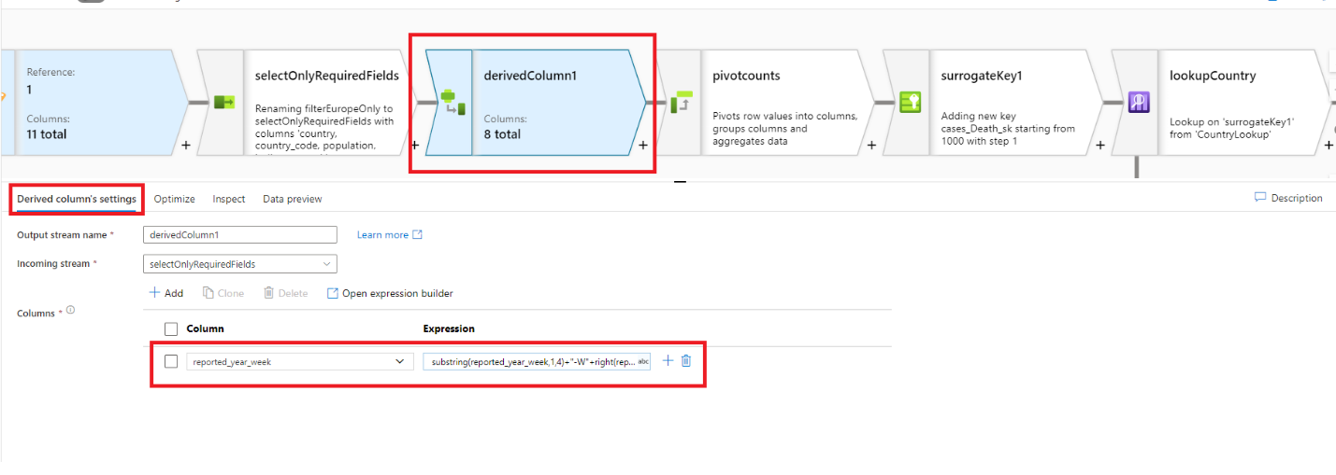

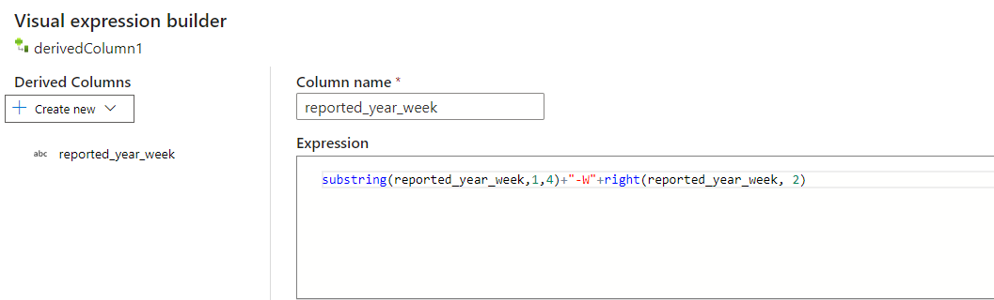

substring(reported_year_week,1,4)+"-W"+right(reported_year_week, 2)

To achieve the data in required format we use substring to get the first four characters of the string which is year value. Then we had to append this string with “-W”. To fetch the week number, we made use of right function to get the last two digits from the original reported_year_week string.

**Pivot Transformation.** 

***Pivot settings: -***

The Cases and Death data has indicator column which specifies whether the row details are about the death or covid cases. To get the total cases and deaths for every week we need to convert the values of indicator column which is cases and deaths to Count of Death and Count of Cases. This can be achieved by using pivot transformation as shown in the figure. Total death and cases are calculated by grouping country, country code, population, source and reported_year_week.

The pivot keys used here are from indicator column which is cases and deaths. Using sum function on weekly_count and above-mentioned group by columns we were able to achieve this.

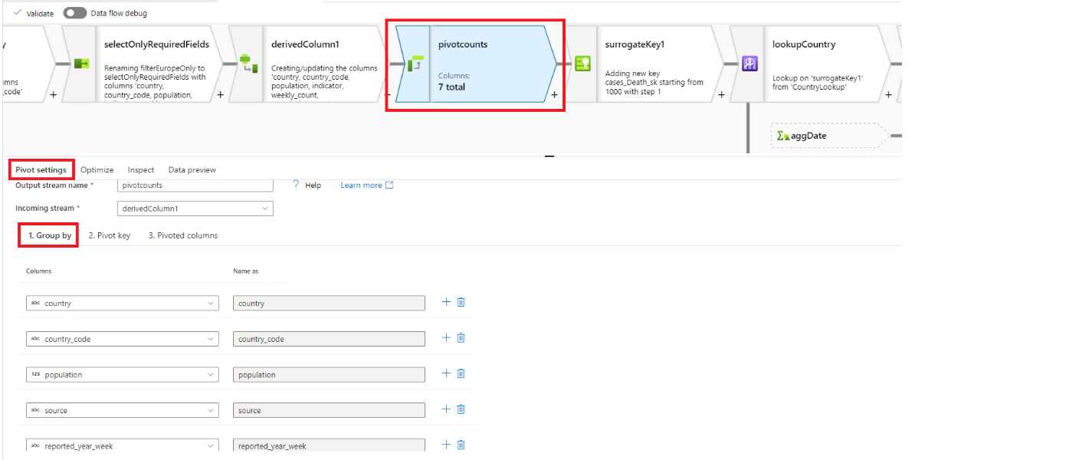

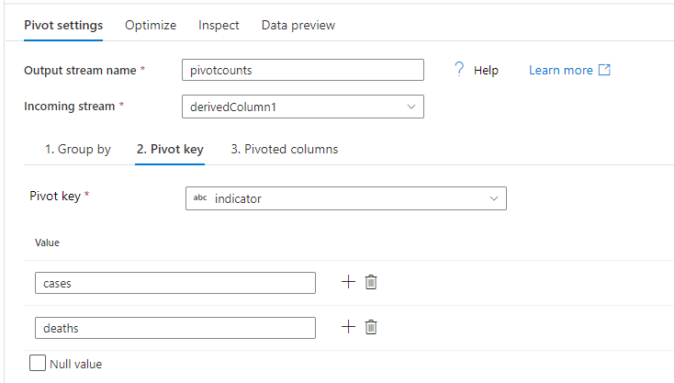 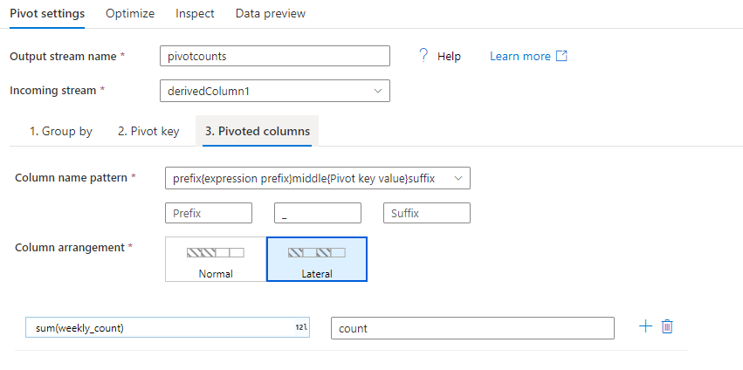

**Surrogate key Transformation.** 

***Surrogate key settings: -***

The surrogate key can in introduced via this transformation or while the records are loaded to relational database table. As this transformation will create a new column, we specify the key column name and starting value of the surrogate key. We also mention the step value by which each value will be incremented.

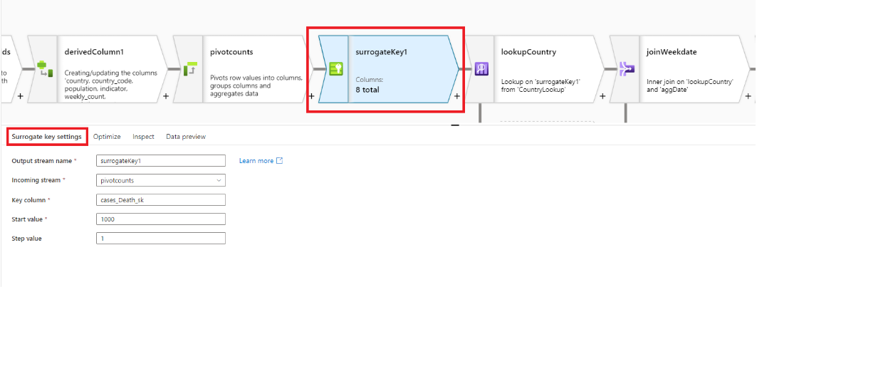

**Lookup Transformation.** 

Our data source for cases and deaths has three-digit code for all the countries. Here with the help of Country mapping table we are adding the country two-digit code to our dataset. This is done with the help of lookup transformation.

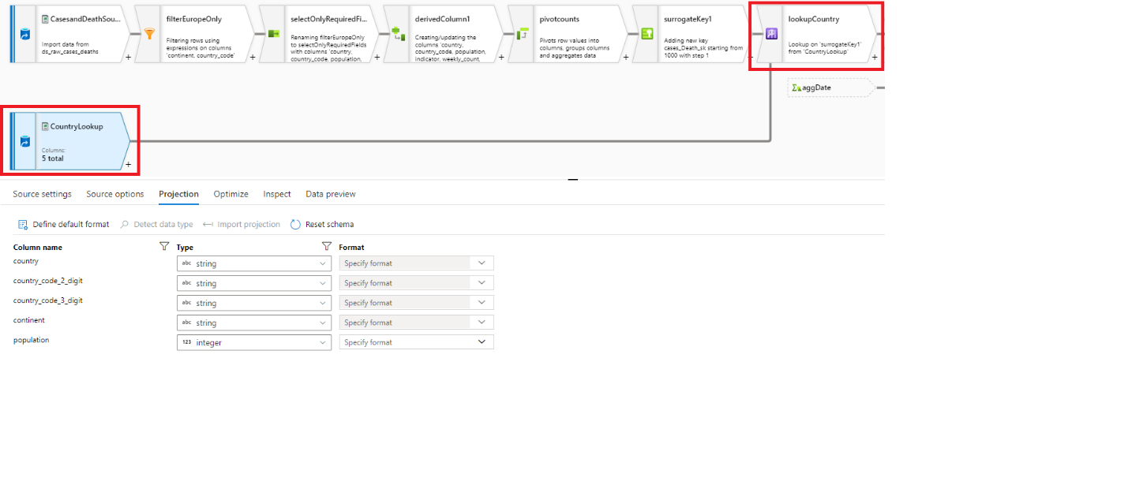

***Lookup key settings: -***

The lookup transformation will have to input stream, one primary stream and second lookup stream. We are looking up for the country value from primary stream i.e., surrogate transformation to lookup stream i.e., CountryLookup.

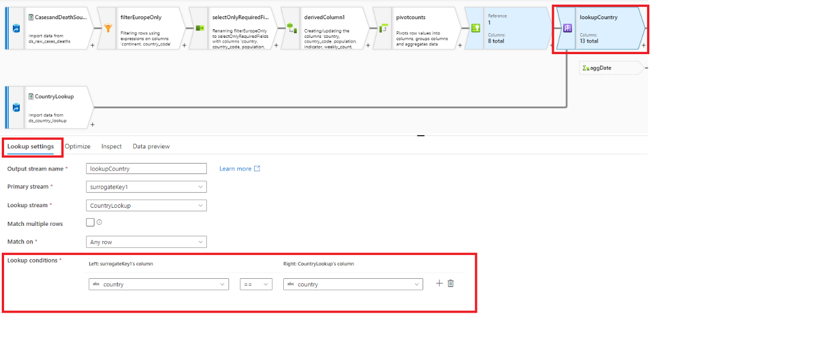

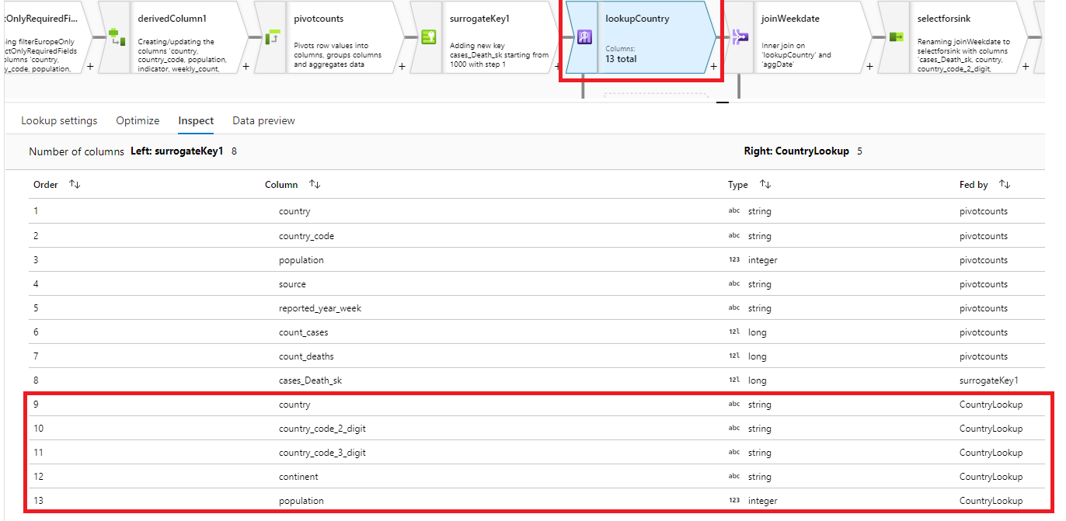

**Aggregate Transformation.** 

To observe the cases and deaths trend over the week start date and week end date, we should induce two new columns, which is week_start_date and week_end_date. To do so we are referring to Dim Date table, group all the dates by reported_year_week and use the min(date) and max(date) aggregation to obtain the start and end of the week values.

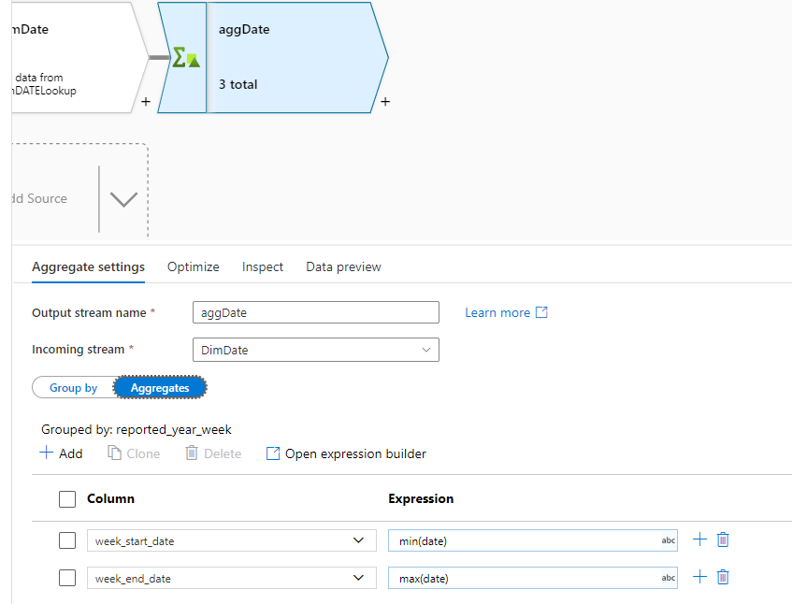

**Join Transformation.** 

***Join settings: -***

Making use of join transformation we are inducing the newly created column from previous transformation i.e aggDate (week_start_date, week_end_date). On here we are making use of inner join on reported_year_week values.

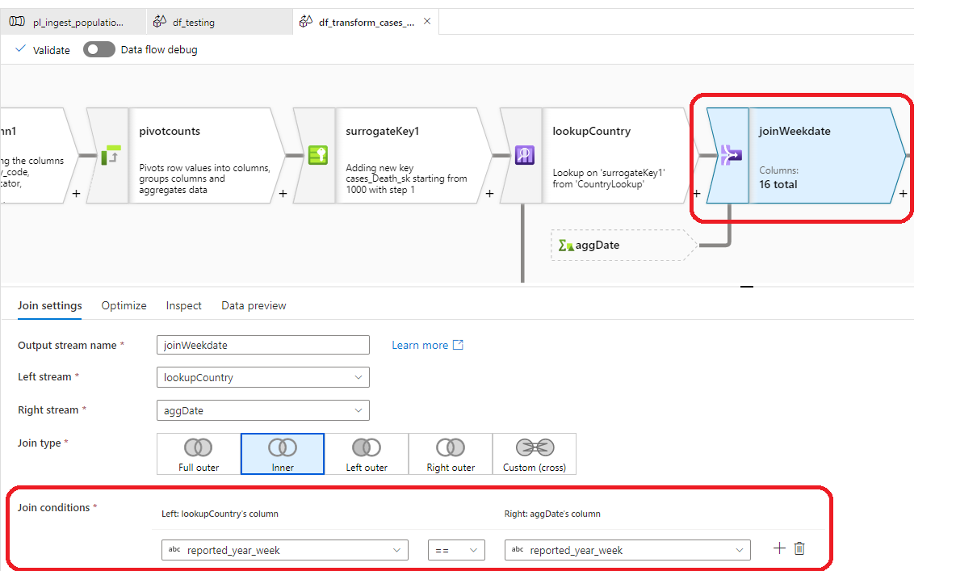

**Select Transformation.** 

***Select settings: -***

After Lookup and join transformation this data flow has few columns which is of no interest to answer the business questions. So, we are making use of select transformation to drop the unwanted columns.

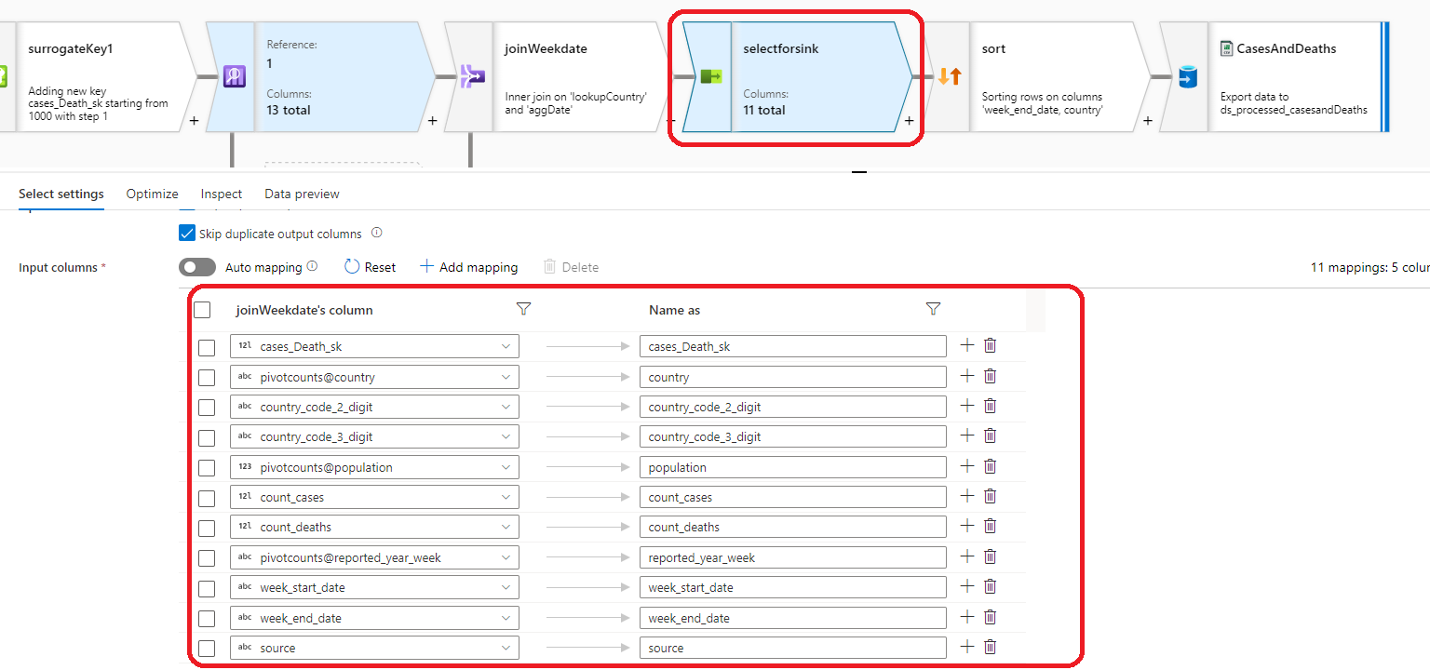

**Sort Transformation.** 

***Sort settings: -***

The purpose for use this transformation is make the latest data to be displayed on top of the table. So, to achieve this, first we are ordering week_end_date in descending fashion and then country in ascending fashion.

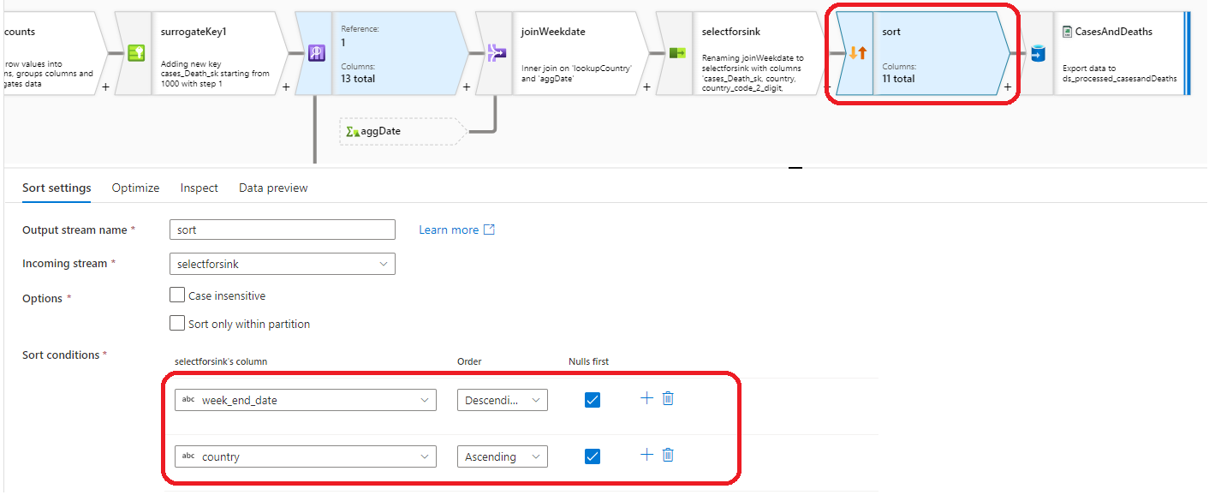

**Sink Transformation.** 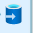

***Sink settings: -***

This transformation is similar to OLE DB destination in SSIS. In here we specify the output to be stored in single file and specify the file name and its format.

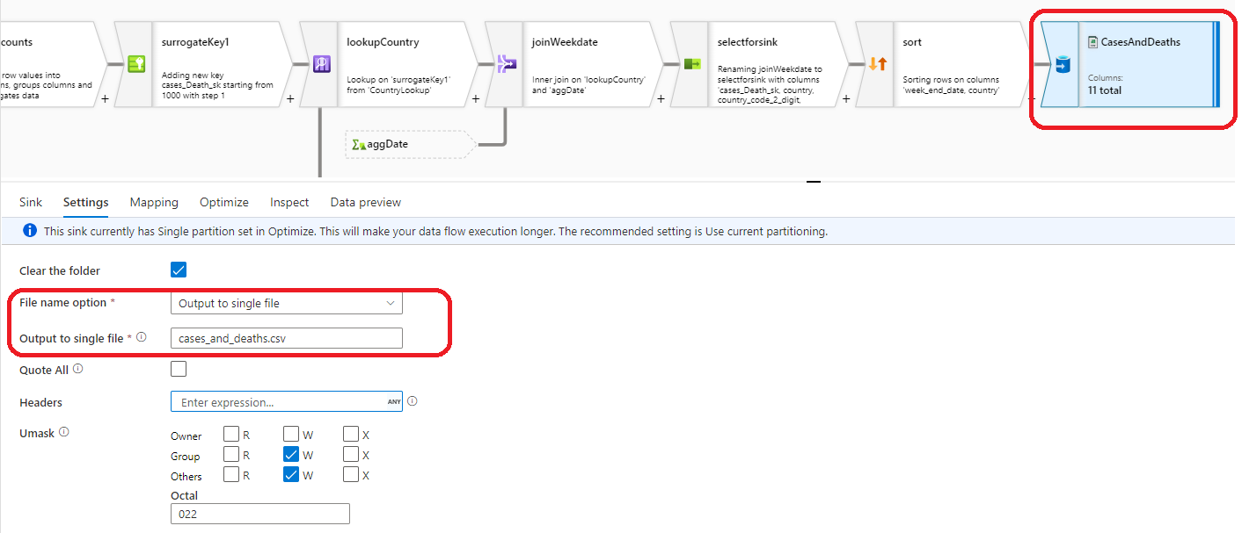

**Transformation of Hospital Admission and ICU Occupancy data.**

This data set has the information about the Covid-19 Hospital Occupancyand ICU Occupancyacross the Europe. This is data set has 7 columns and they are country, indicator, date, year_week, value, source and url. All these columns may not be of our interest hence few columns will be dropped out. At the same time, we will need some extra columns to answer the managerial questions, so we will be performing numerous transformations.

The main purpose of this data flow is to achieve the transformation shown in the below mapping figure. The source dataset has the details of the Hospital Occupancy and ICU Occupancycount on daily basis for Europe. The indicator column specifies if the row observation is about Hospital occupancy or ICU occupancy. To answer the business questions, which is find the total Hospital occupancy and ICU Occupancy for every week as we as on daily basis. To achieve this transformation, we made use of Split transformation in data flow.

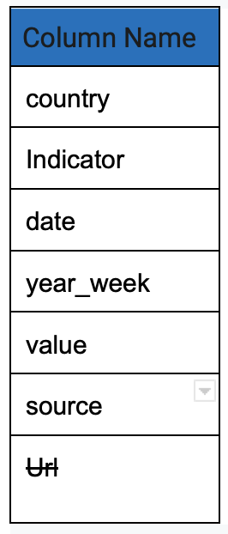 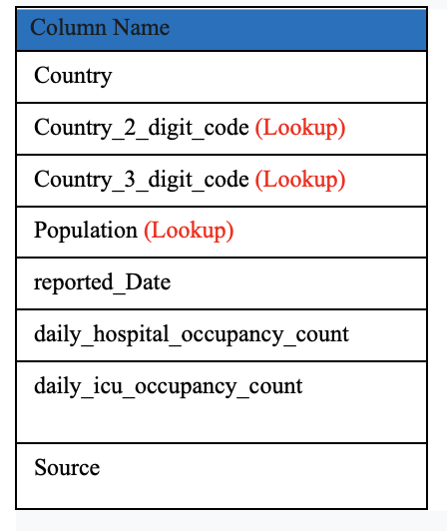

**Daily Hospital and ICU Occupancy**

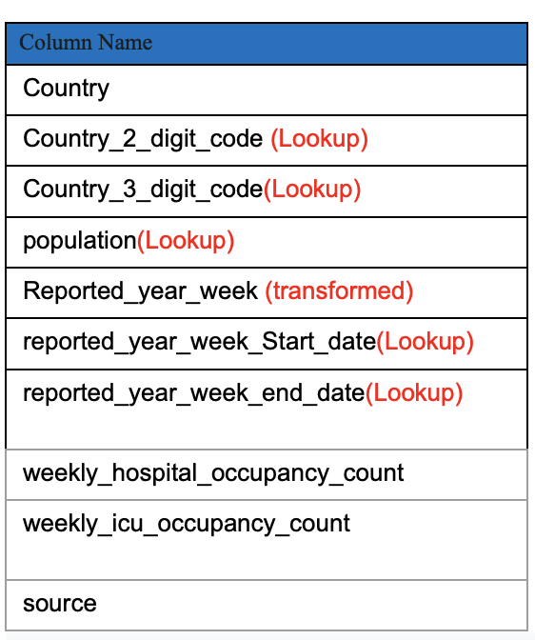

**Weekly Hospital and ICU Occupancy**

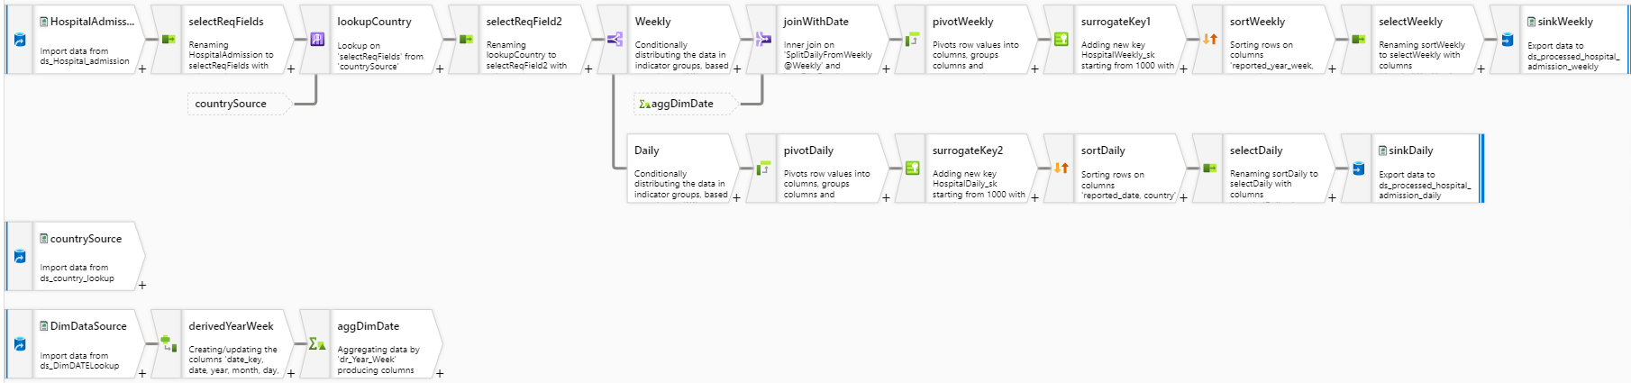

All the transformation in the above diagram is almost same as we did for cases and death data. The new and interesting transformation in this data flow is Split transformation.

**Source Transformation.** 

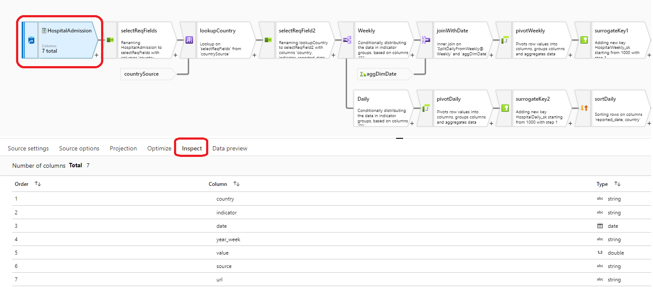

**Select Transformation.** 

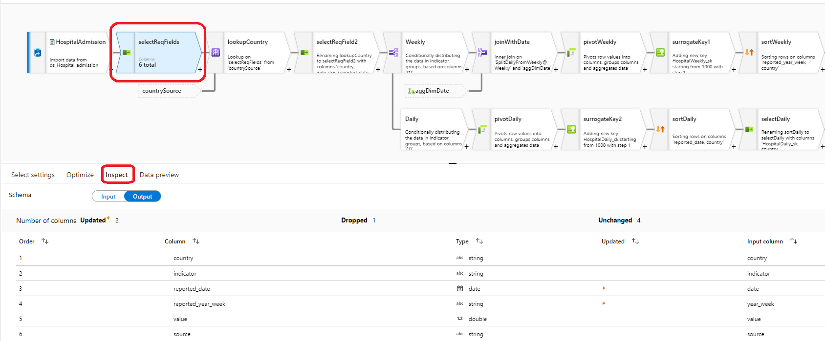

**Lookup Transformation.** 

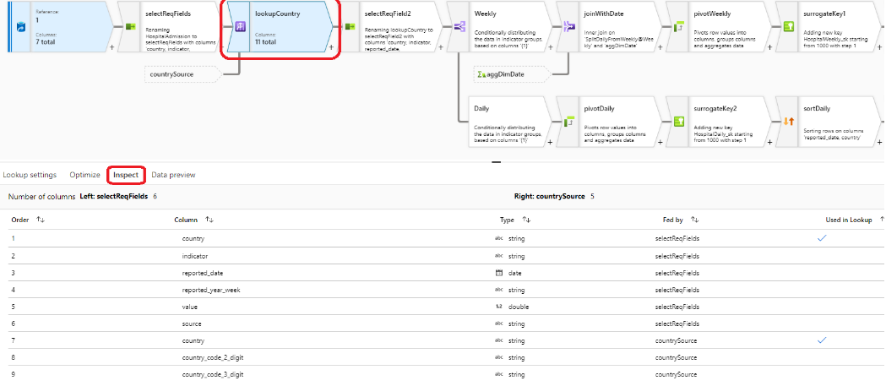

**Select Transformation.** 

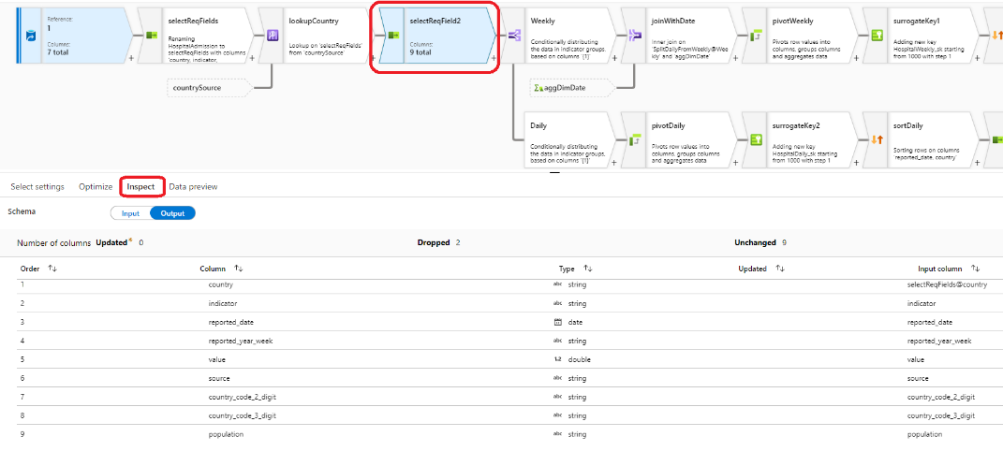

**Split Transformation.** 

***Conditional Split settings: -***

In here we specify the conditions for splitting the data into two different streamlines which is weekly and daily. Based on the values from the indicator column, the row which satisfies

“indicator == 'Weekly new hospital admissions per 100k' || indicator == 'Weekly new ICU admissions per 100k'” this condition will be grouped into weekly streamline. Those rows which fail to satisfy this condition will grouped into daily streamline.

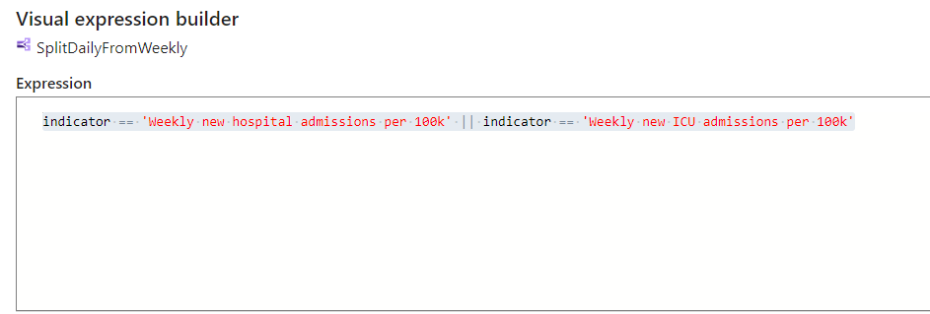

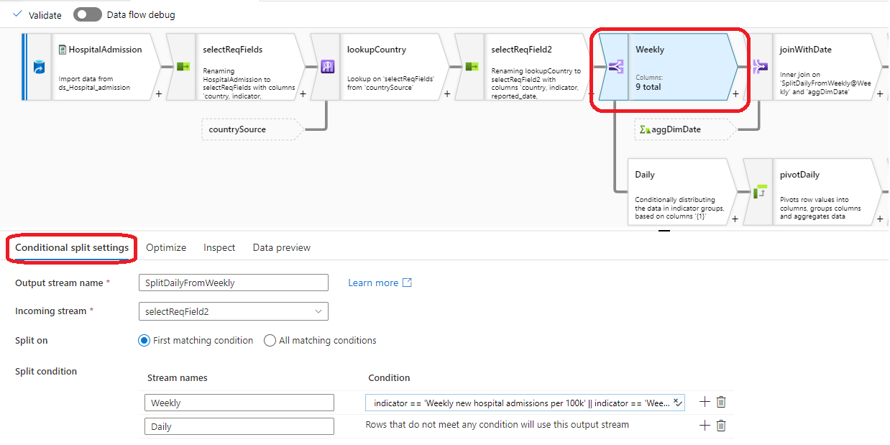

Rest of the tranformation follows same order of transformation from cases and deaths data flow.

**Sink Transformation.** (Weekly data)

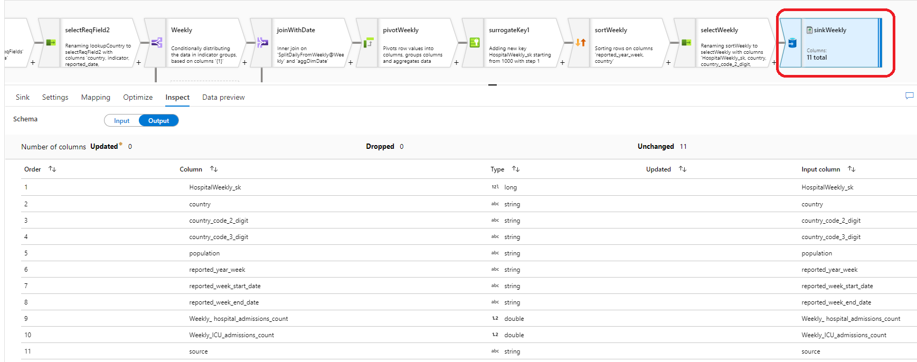

**Sink Transformation.** (daily data)

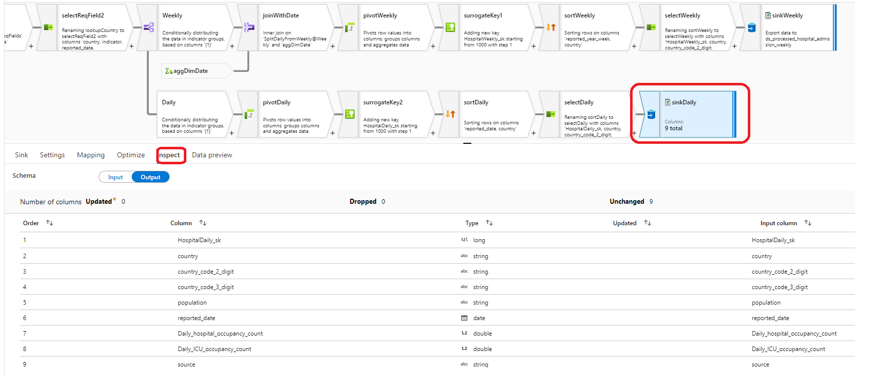

**Transformation of Covid-19 Testing data.**

The tetsing data from ECDC websites has the details of total Covid-19 testing count, postivity rate, testing rate, total number of cases for every region in european countries. These details in this file are grouped by Nation wise as well as for each region (Sub nation). Due to this format, we cannot perform the aggregation directily on this file because of the redundant data.

As our area of intrest is in to answer average positivity rate for europe, total testing done for million population, Average testing rate for 100k population and observe all these parameter over every week, we will be performing below shown transformation.

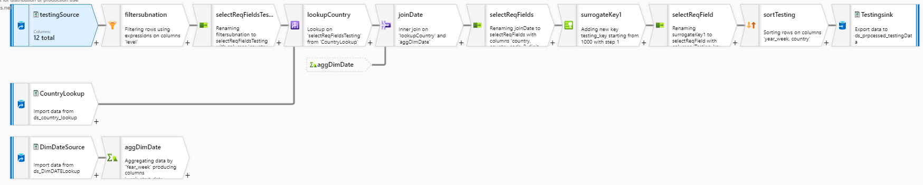

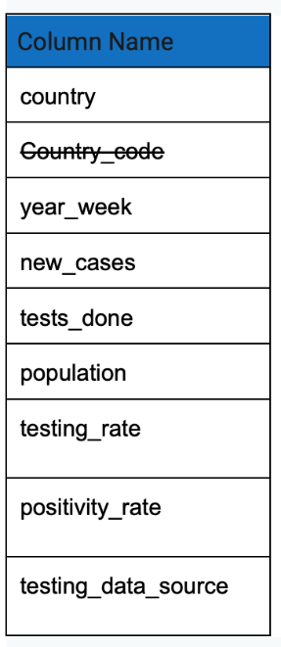 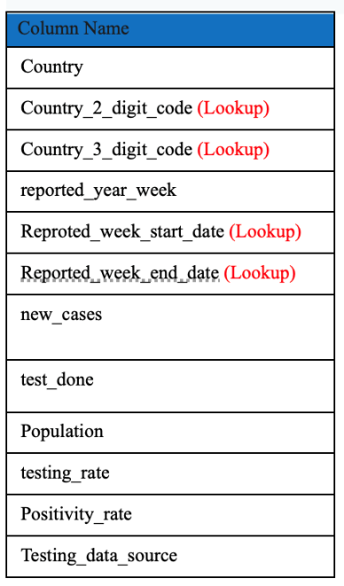

**Source Transformation.** 

Using Source transformation, we create a connection to testing data set in the Azure data lake Gen2 and with the help of project we make sure schema is well defined.

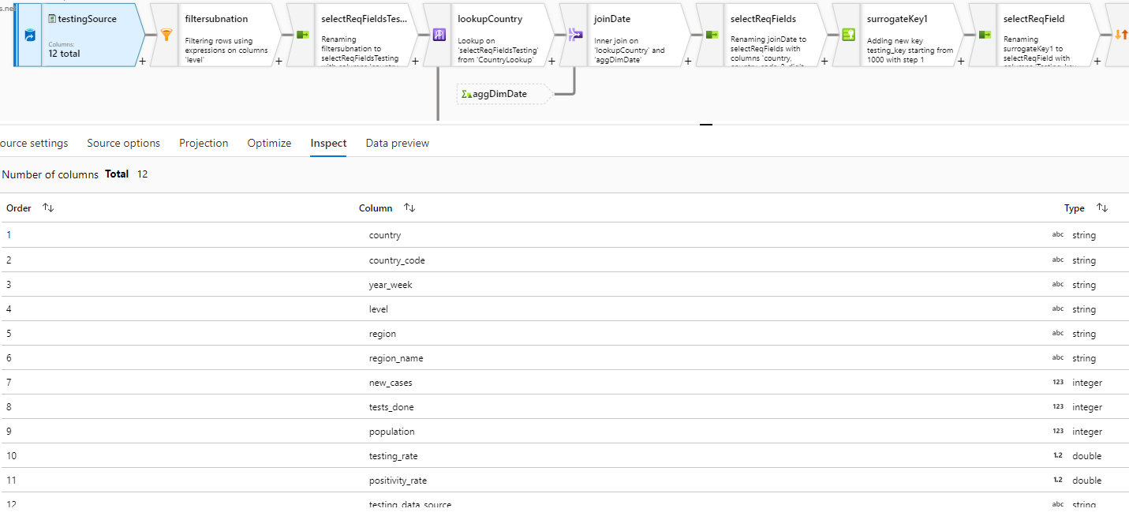

**Filter Transformation.** 

As we are interseted only about the testing and postivity rate for National level we filter out the row with respect to subnational by mentioning the filter condition shown below.

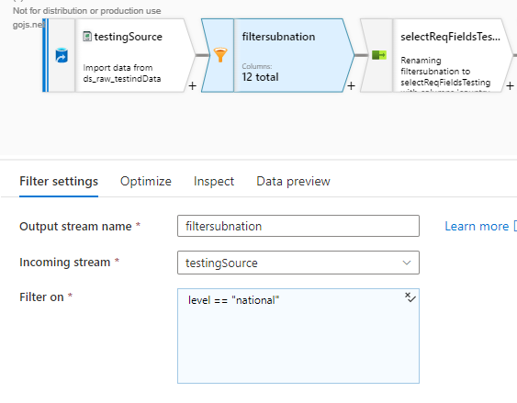

**Select Transformation.** 

With select transformation we are exclude the country_code column, because later part of the transformation we will looking from the country dim table to obtain the 2- and 3-digit country code. To avoid the redundancy of data we are performing this transformation.

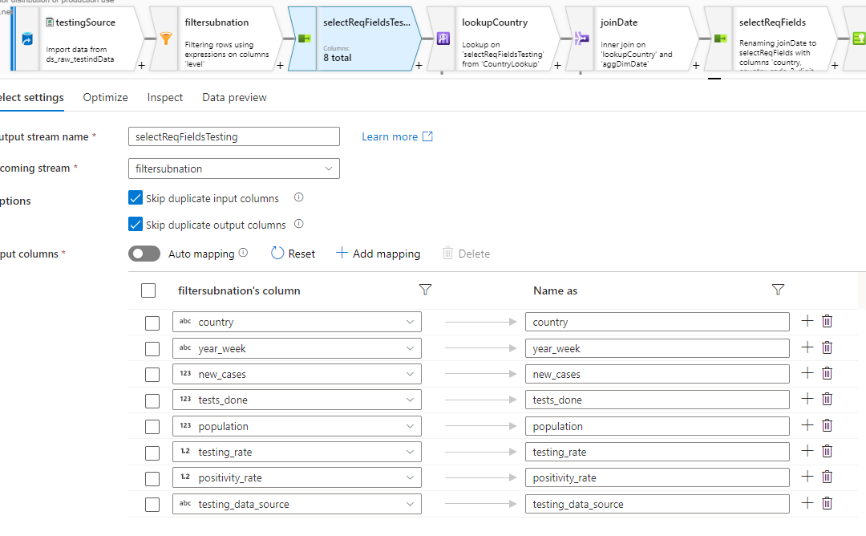

**Lookup Transformation.** 

To fetch the country two and three digit code we are looking up to the dim country table. The lookup key used here are the country value from source and dim country table.

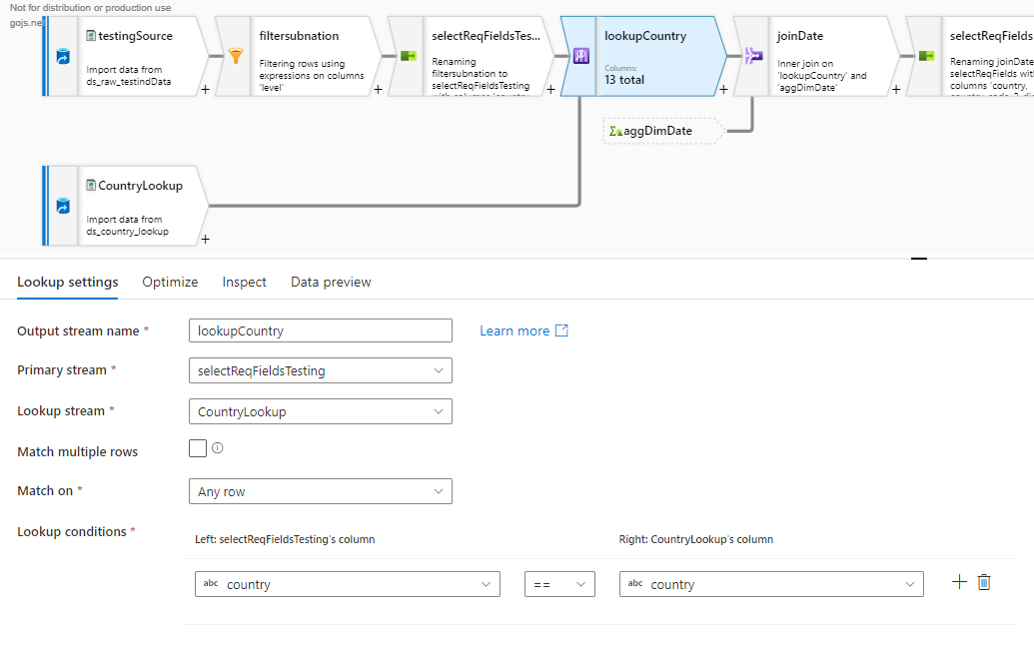

**Join Transformation.** 

The input soure file has the reading of the testing details for every week and the week is represented in “yyyy-weekNumber”. For better filtering and better readeablity for data we are creating the two column called week_start_date and and week_end_date whose data are in date format.

To achieve this we are making use of dim date table to derive the week_start_date and week_end_date via aggregate transformation.

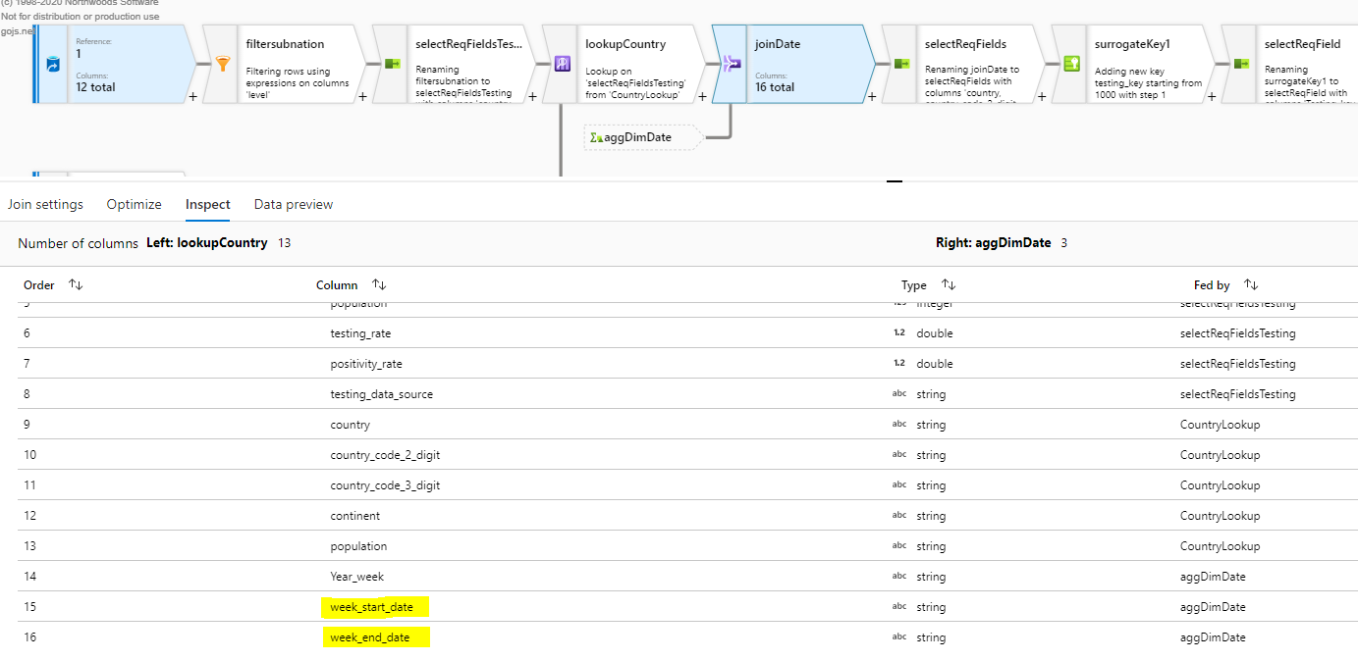

**Surrogate key Transformation.** 

The surrogate key can in introduced via this transformation or while the records are loaded to relational database table. As this transformation will create a new column, we specify the key column name and starting value of the surrogate key. We also mention the step value by which each value will be incremented.

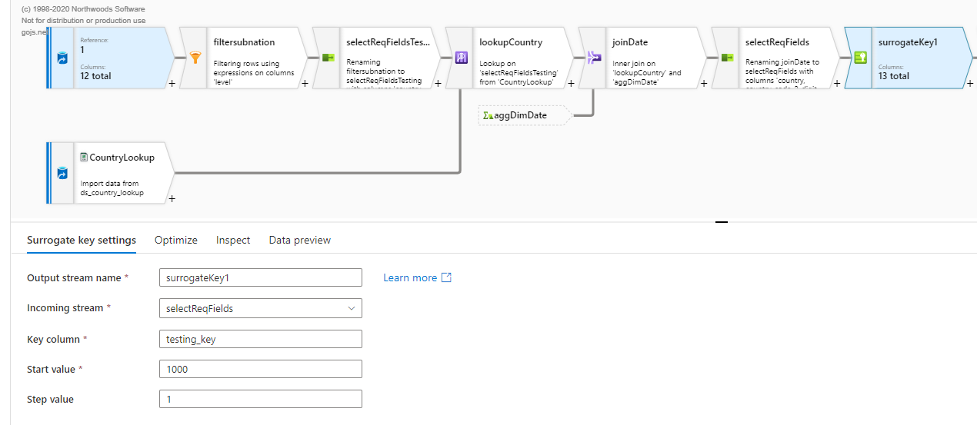

**Sort Transformation.** 

The purpose for use this transformation is make the latest testing and positivity data to be displayed on top of the table. So, to achieve this, first we are ordering week_end_date in descending fashion and then country in ascending fashion.

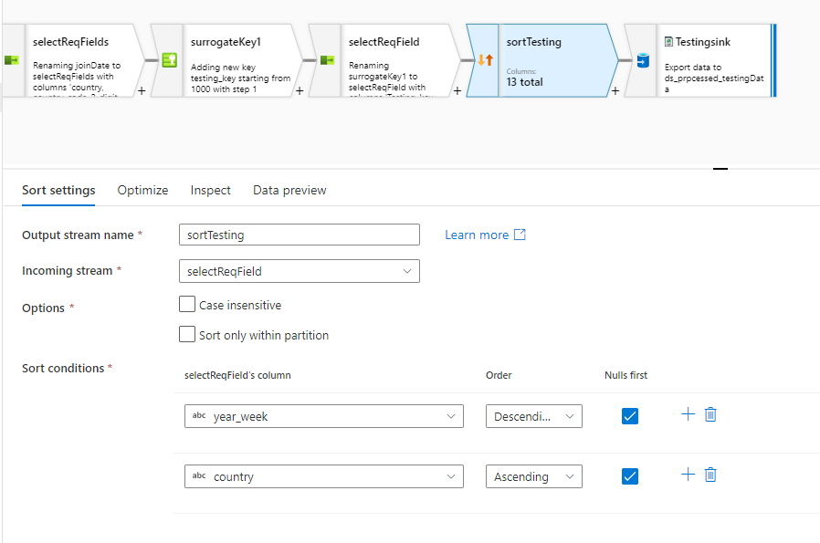

**Sink Transformation.** 

Sink Transformation is establishing the connect with destination data set that has to be stored in processed folder of Azure Data Lake Gen 2. In here we specify the output to be stored in single file and specify the file name and its format.

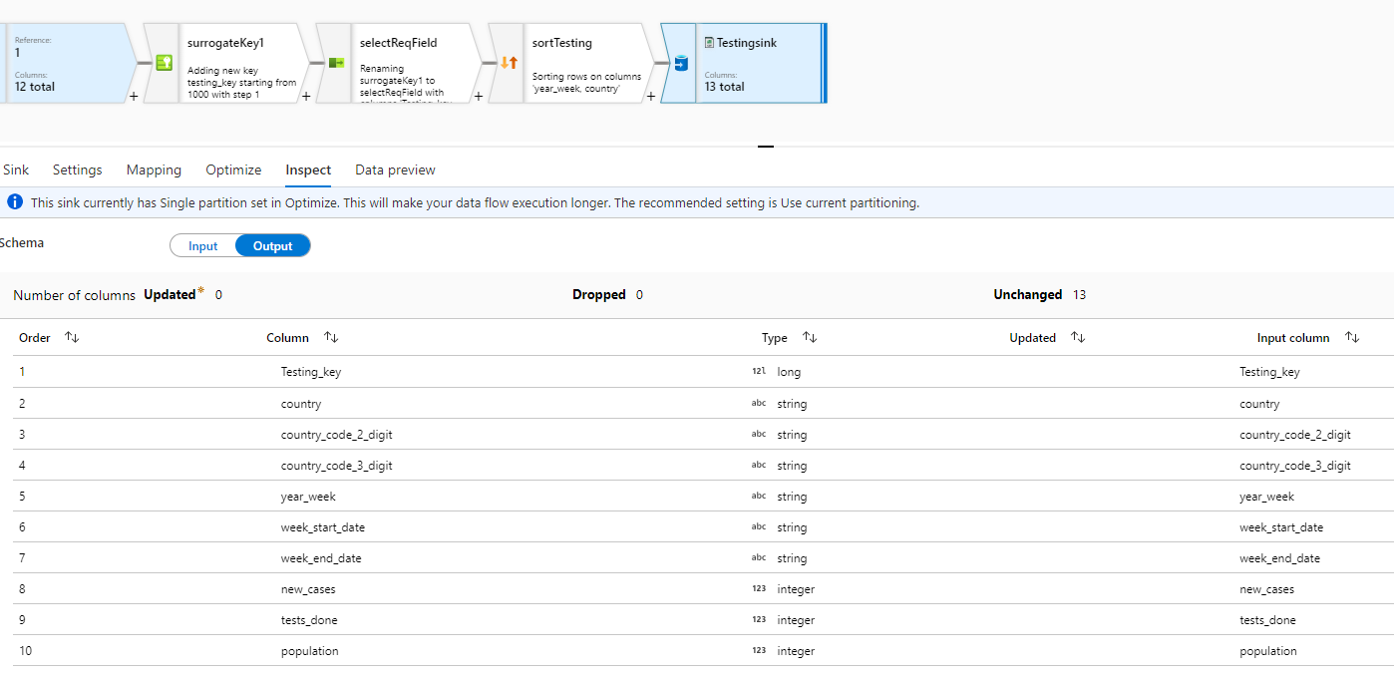

**Pipeline.** (**Data** **Transform pipeline**)

The data flow which we have created can not run one its own. So, to automate any process in the data factory we need to use the pipelines. In this project we have created the pipelines for Data Ingestion from the Azure data lake Gen2 and Azure Blob storage. Similarly, we have respective pipelines of to run the data transformation and Data loading jobs.

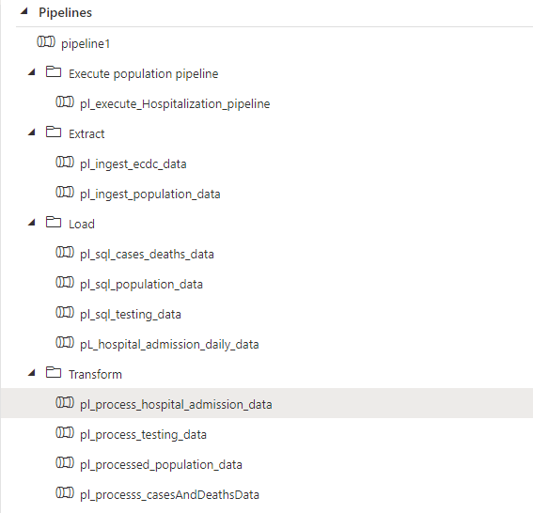

***Transformation Pipelines.***

Cases and Death Data Transformation pipeline.

In General tab we specify the Timeout. By default, the timeout is 1 day, and maximum value can be for 7 days. Retry parameter takes the value of total retry attempts during the specified timeout. Retry interval takes the input value for time gap between the retry attempts.

In Settings we specify the dataflow that must be executed, Integration Runtime, Compute type (required for spark cluster) and core count.

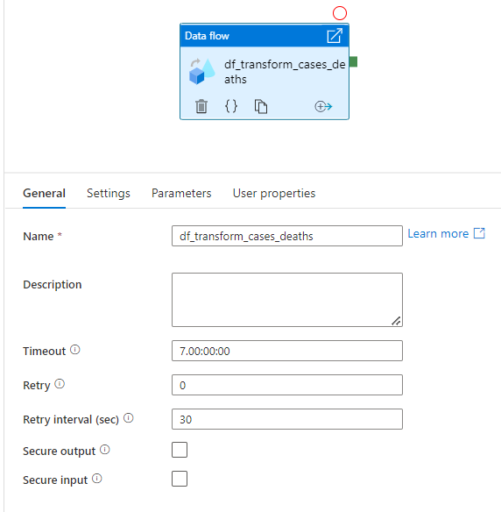 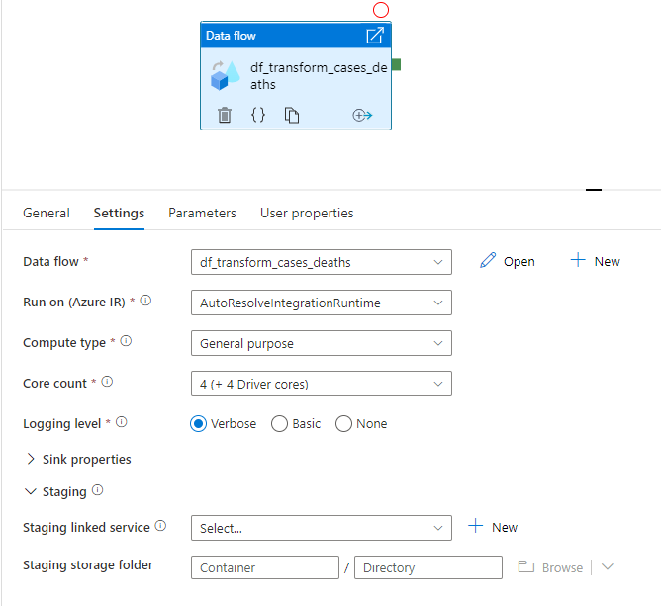

Hospital Occupancy and ICU Occupancy Transformation pipeline.

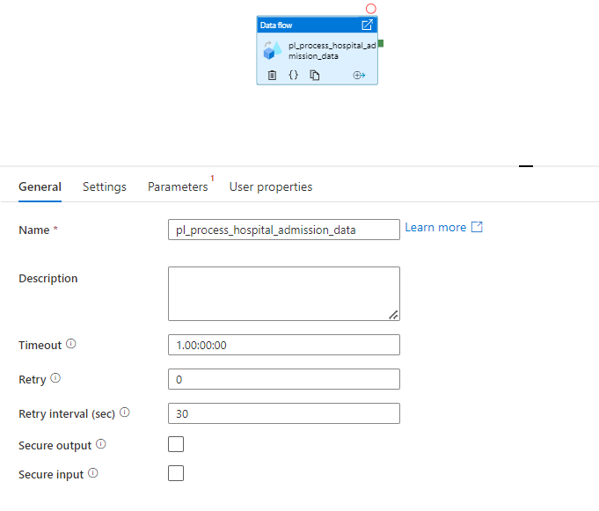 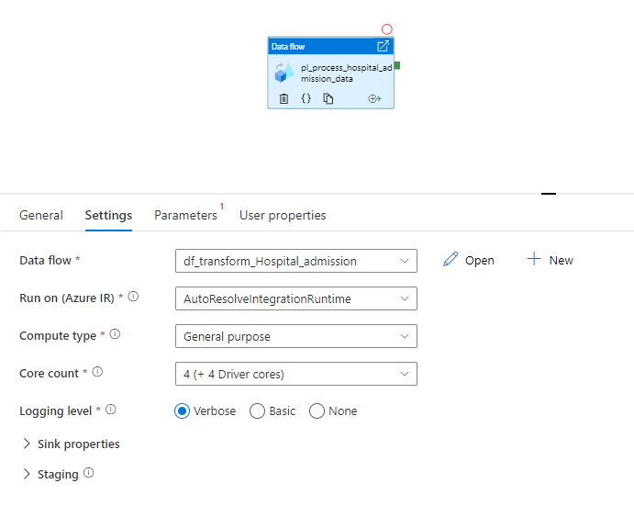

Testing Transformation pipeline.

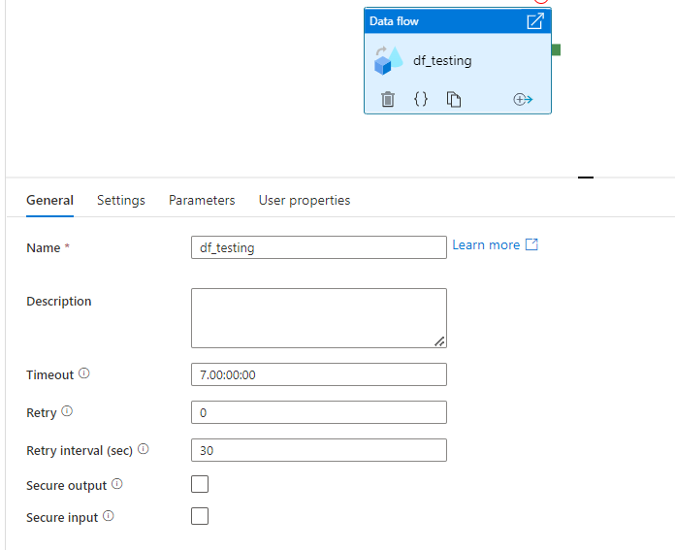 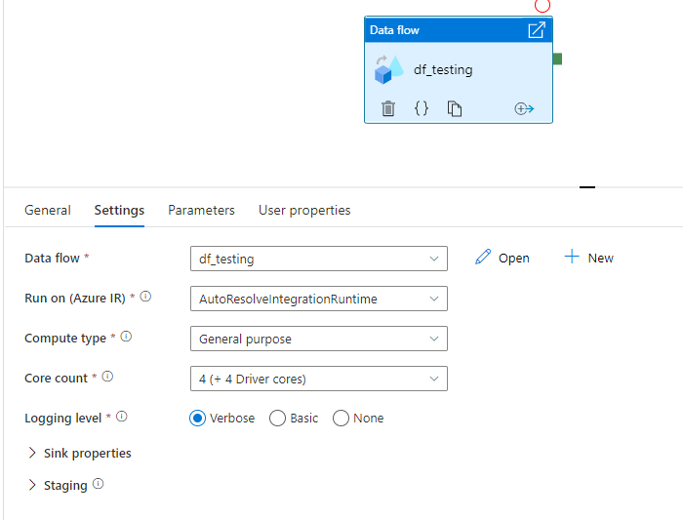

***Copy To SQL***

The first step in this phase will be to create the schema and tables within the Azure SQL Database so that the data has a place to go. Below is an example of the sql statement used to create all the tables and schema.

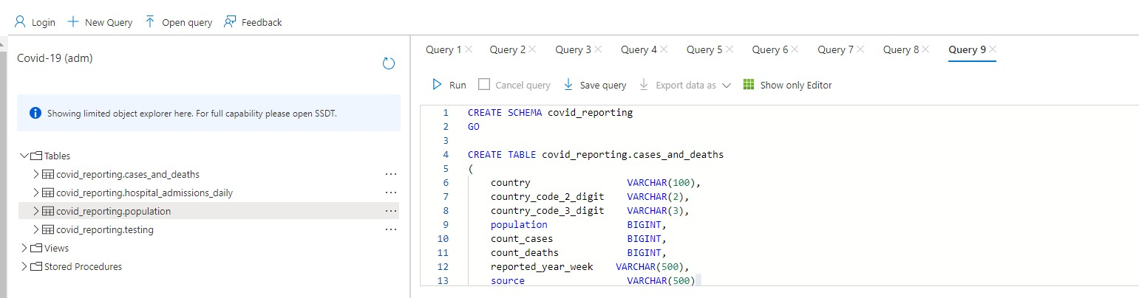

Then, we had to create a pipeline to copy this data into the Azure SQL Database.

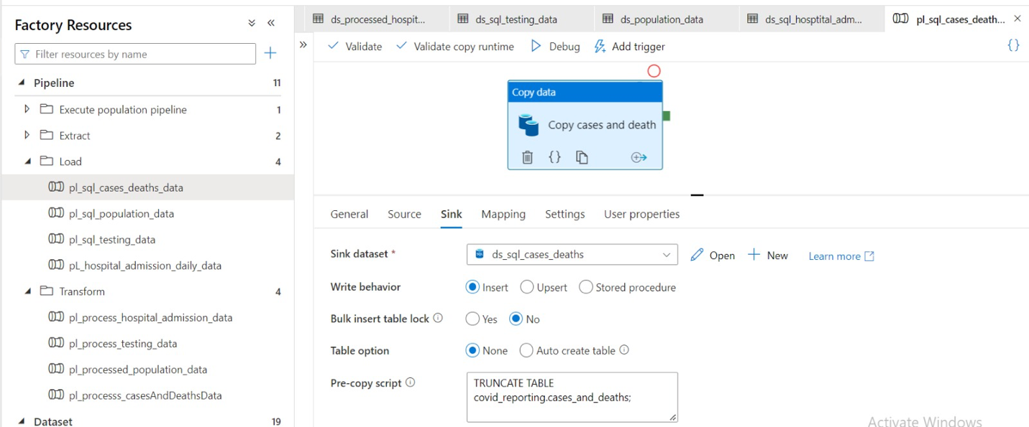

The first pipeline was for the cases and deaths data. We used a copy data activity and specified the source dataset which is the cases and deaths data from the processed folder in the Azure data lake gen 2 storage account and the sink dataset which is a new dataset that we created. We also make sure to use a TRUNCATE TABLE statement to any of the existing data in the table before copying the data. This ensures that there is no redundant data within the table.

These same steps were taken for the population, testing and hospital/ICU admissions data. When the pipelines were run, all of the data was copied to SQL. Below is a screenshot showing the first thousand rows populated with the transformed data from the processed folder of the Azure data lake gn2 storage account.

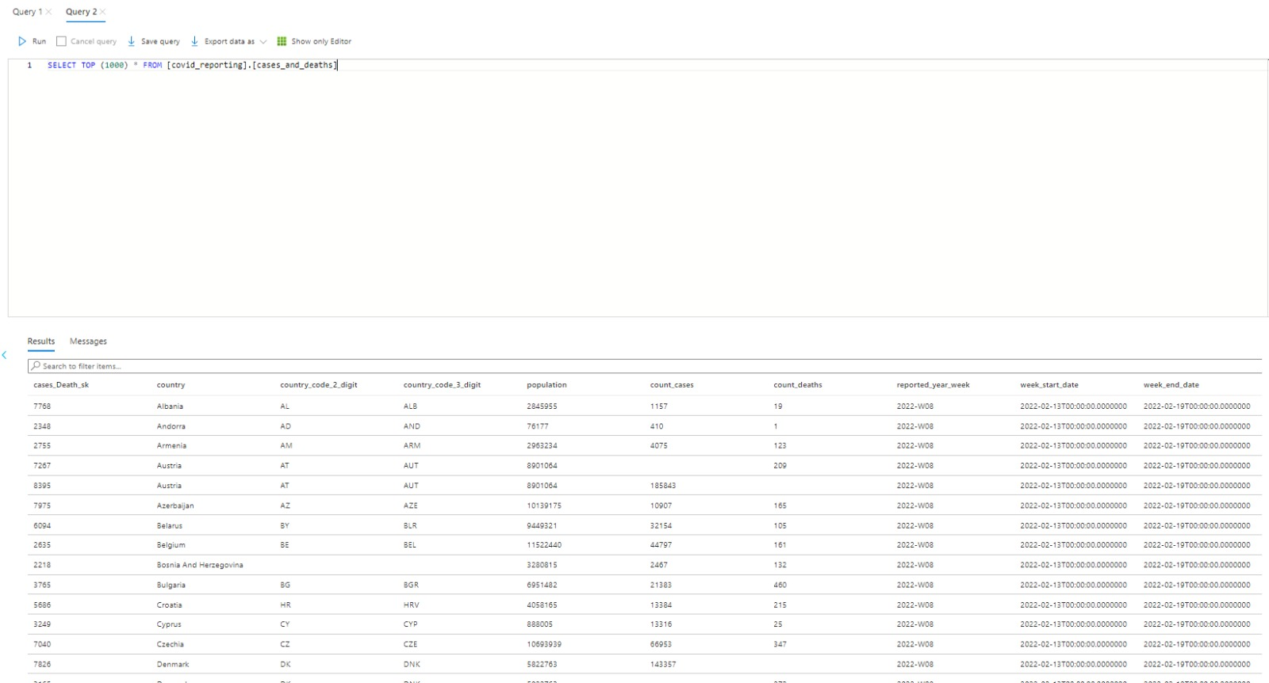

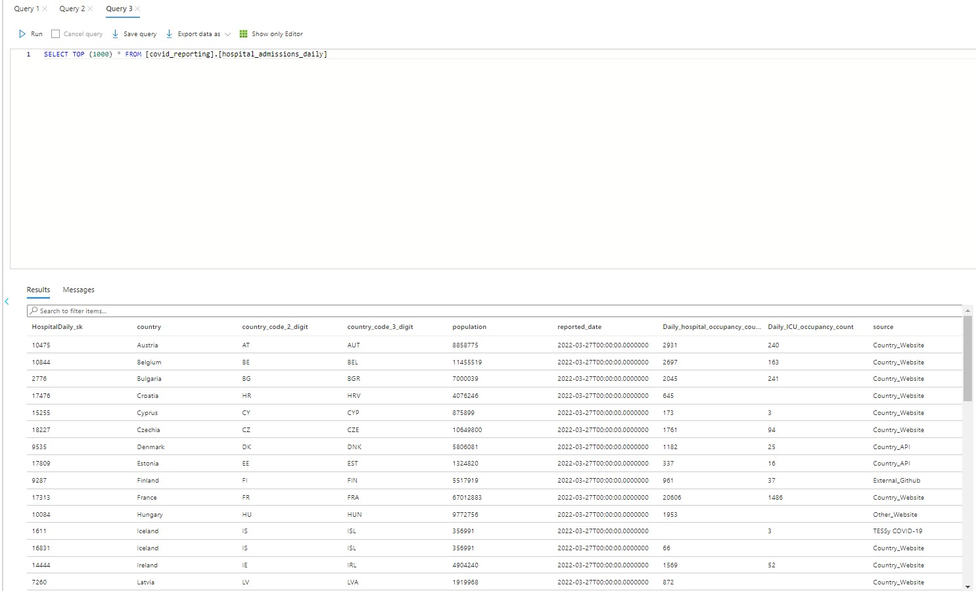

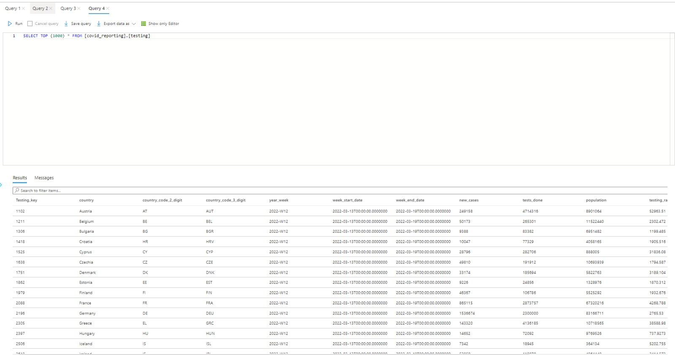

***PowerBI Dashboards***

We were able to answer few managerial questions by creating the PowerBI reports.

As all our data in stored in Azure SQL server, we need to establish the connect between the database and powerBI.

To do so we need the server information, database name and login credentials.

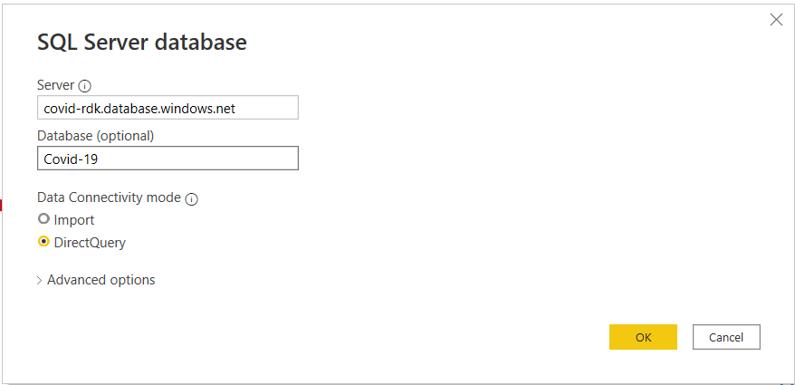

To answer few not so simple managerial questions we have make use DAX (Data Analytics Expression). Few of such example are to find Cases per million population, Deaths per million population, Death rate, ICU Occupancy rate, Average testing, and positivity rate in Europe.

Below are our managerial quesetions and how we were able to answer them using the dashboards.

How many deaths and cases per million in Europe?

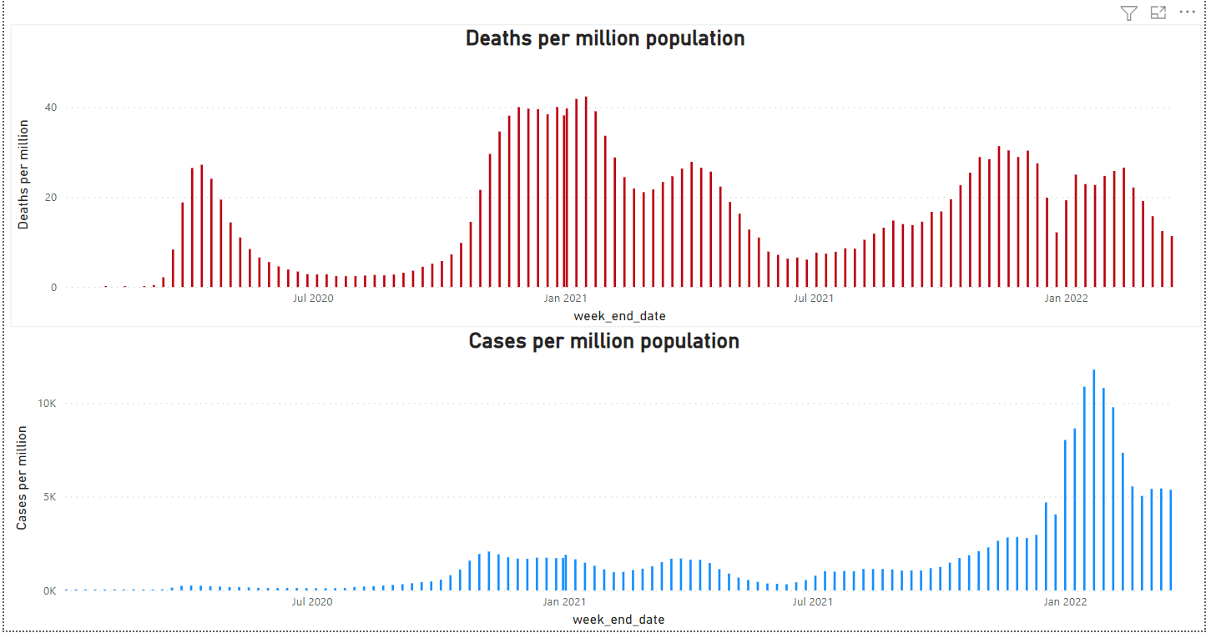

What was the total death rate for Europe?

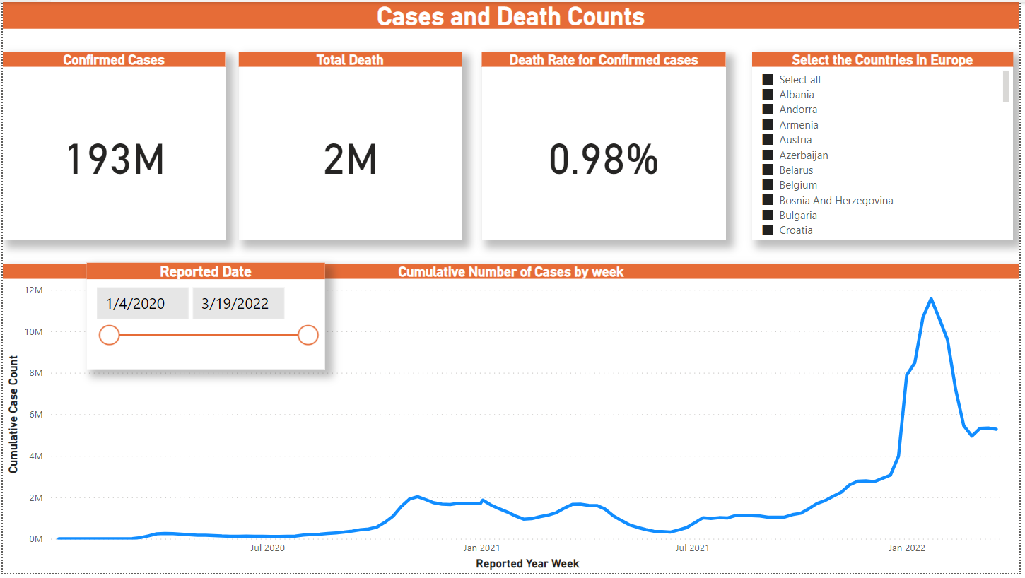

What was the average Covid Positivity rate and average testing per 100k population?

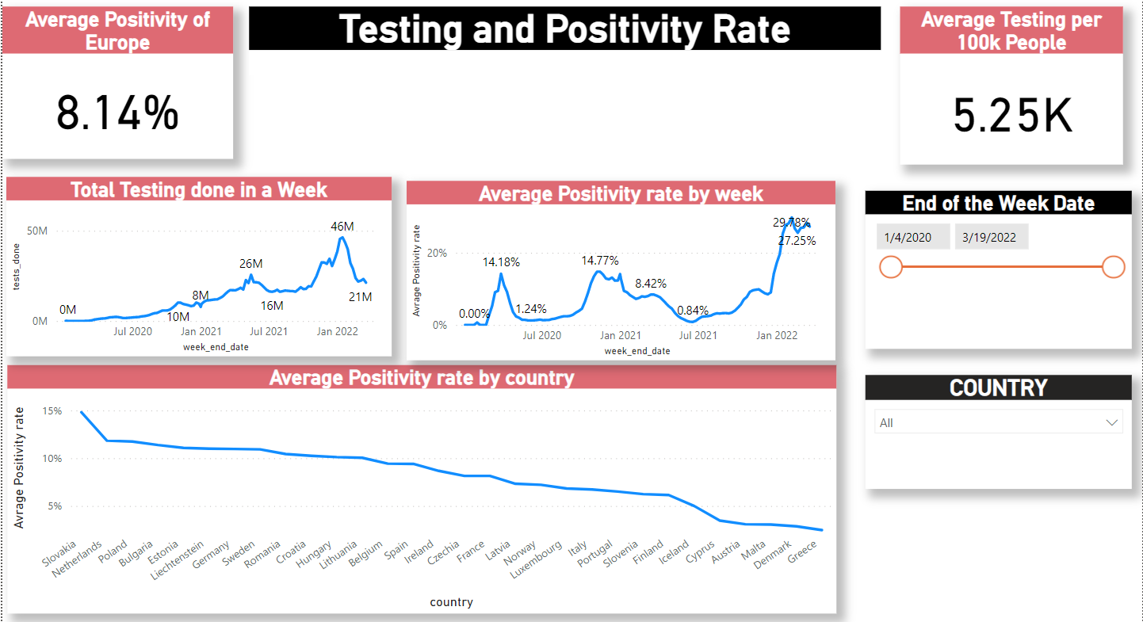

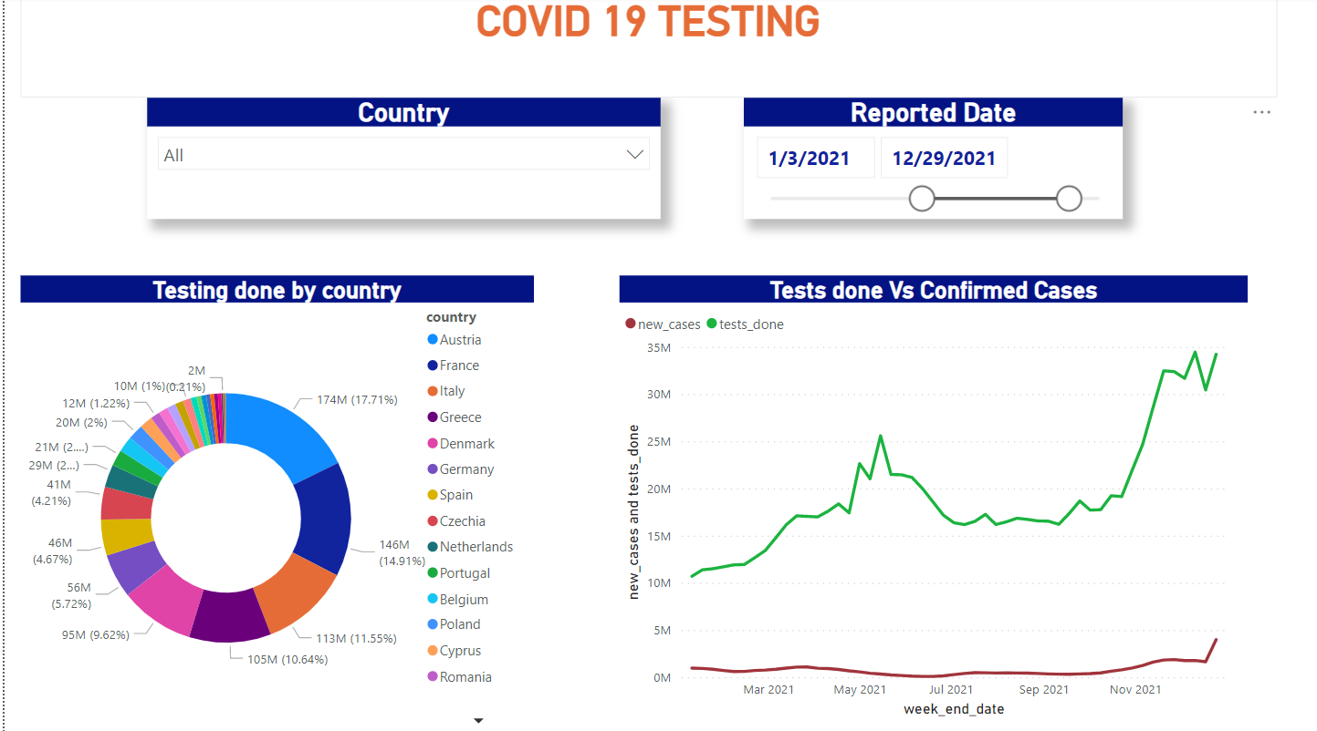

How many Covid cases per week?



What was the Hospital and ICU occupancy over a week?

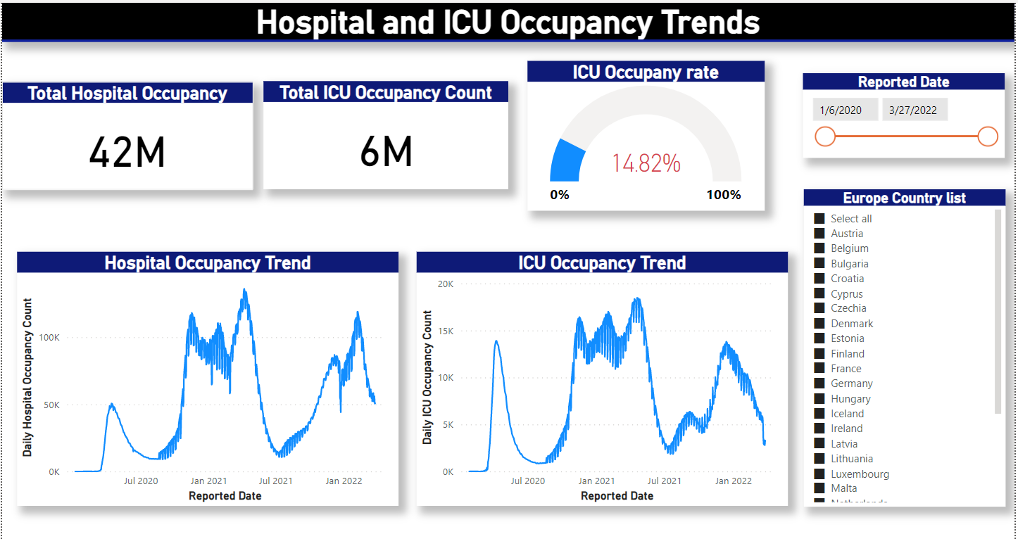

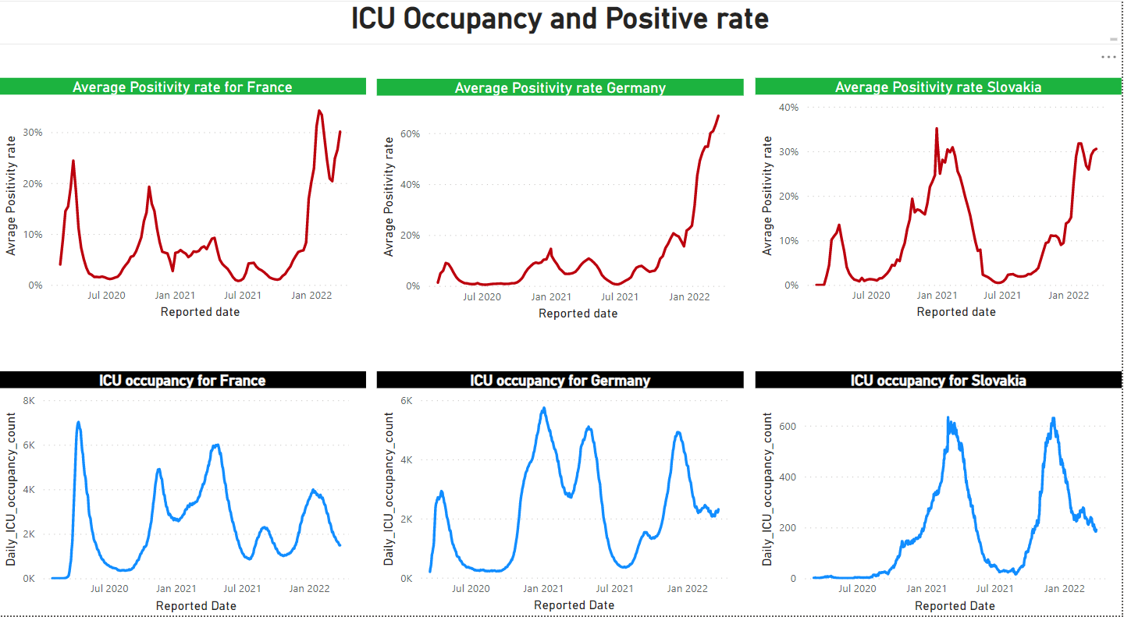

What are the top 15 countries affected most by Covid?

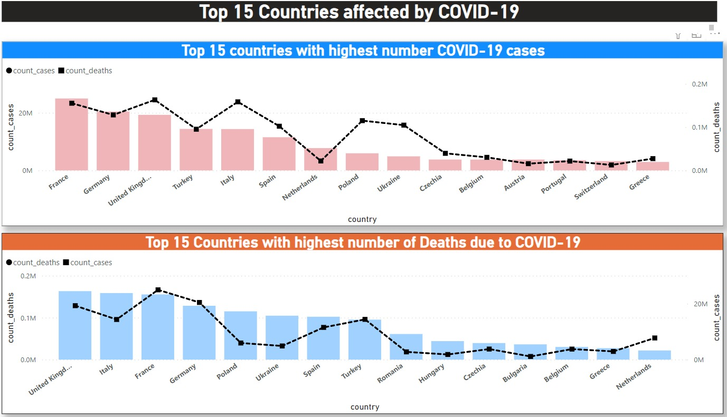

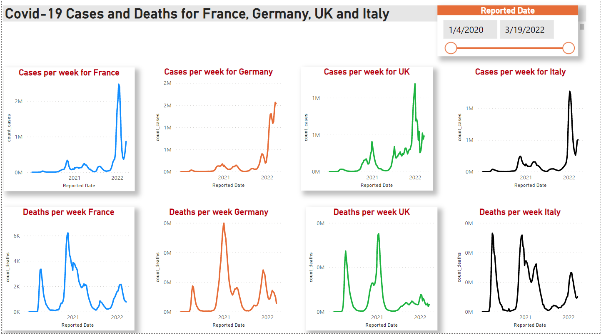

***Triggers/Alerts***To execute a pipeline, we set the trigger. Triggers represent a unit of processing that determines when a pipeline execution needs to be kicked off.

In this project we used following types of triggers:

* Schedule
* Storage Event
* Tumbling window

***Schedule Triggers:***

Each trigger has its own responsibility and purpose. The Schedule triggers used to kick start the pipelines at specified time and date. In here, we can specify the time zone and recurrence which ranges from minutes to months. We can also specify when this trigger should be terminated.

The tr_ingest_ecdc_data triggers every day at 9 pm EST to run the pipeline pl_execute_ecdc_data which creates the http connection to get the data from the website and dump it in Azure data lake Gen2.

Once these triggers are created, we need to attach the trigger to pipeline so that they can run together.

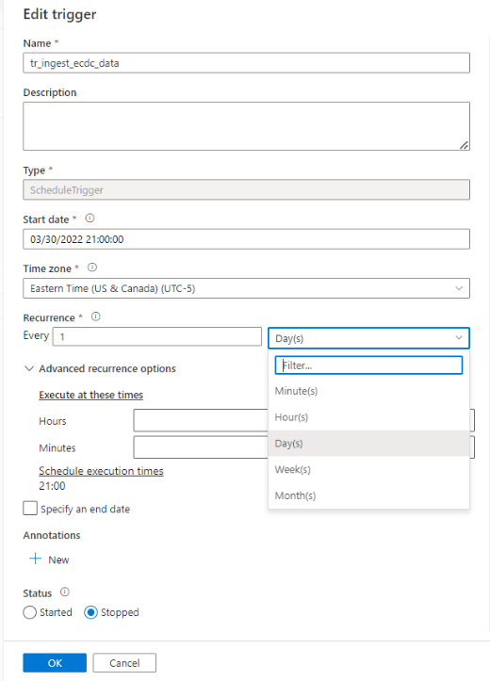

***Storage event Triggers:***

If we wish to trigger the pipeline based on the event happening at the storage account, we define the Storage event trigger. In here we mention Storage account name, Container name and define the event on which this trigger should be run.

There are two events:

* When Blob is created which means data is uploaded
* When Blob is deleted which means when data is delete from the storage account.

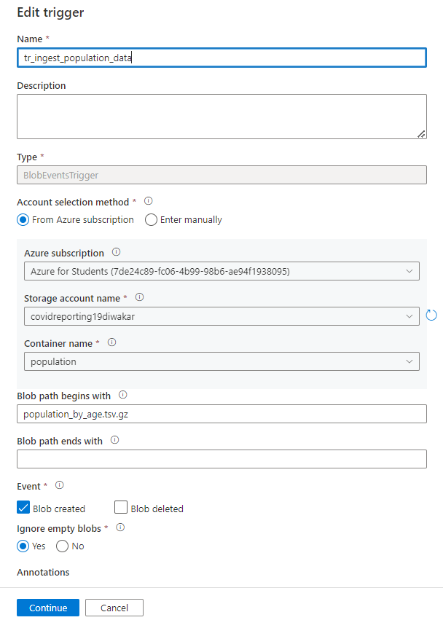

***Tumbling window Triggers:***

These triggers run at a specific time or periodic intervals mentioned in start time column. This is most sophisticated trigger so far in Azure Data factory because of following reasons.

* **Dependency on another trigger:** - these triggers are used when we want multiple pipelines to run. If we run one pipeline, it will trigger the rest to run as well.

In our case, the data transformation pipeline trigger should run only when we have successfully completed the data ingestion pipeline trigger. This dependency can be regulated with the mentioning of the offset values.

* **To process Historical data**: - As the name itself specify the word “window”, upon creation of this trigger we can process any historical data that falls under the certain window period. Using the modified time stamp, this trigger can filter data based on window start time as well as window end time.

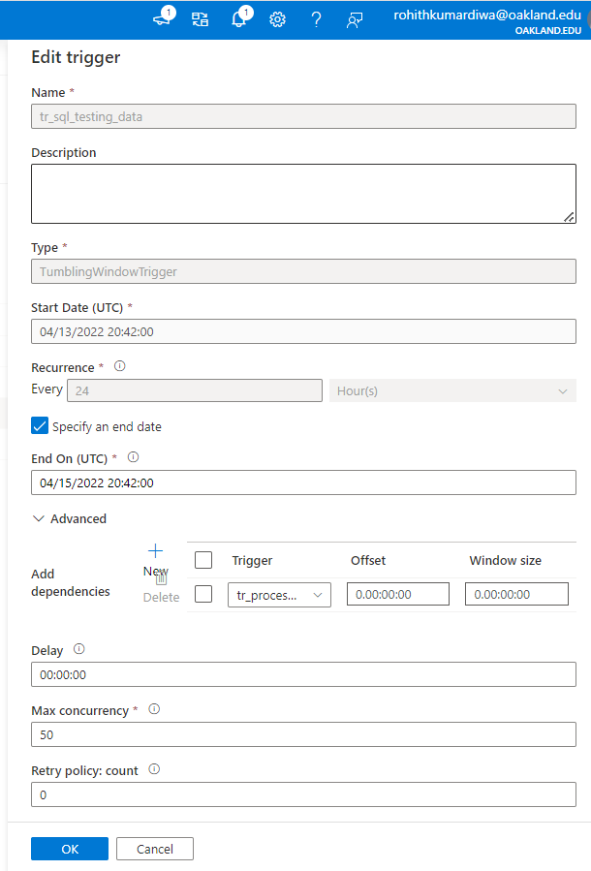

**Monitoring the Pipeline**

***Dashboard:***

The overall summary of the trigger runs, pipeline runs, and activities can be accessed in the Dashboard section of the Monitoring. As each pipeline and trigger run costs us money, we should be making sure everything is in place before its execution. The below screenshot shows the number of times that our pipeline and triggers have succeeded and failed. The overall activity is monitored here.

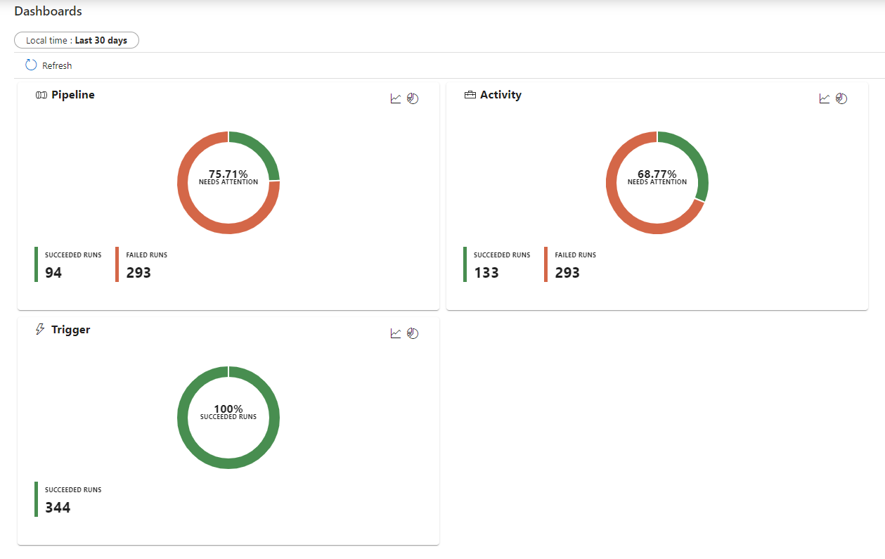

***Alerts: -***

We can create alerts based on the status of the trigger run. In this project we have specified the severity as “0” which means Critical on any failure of the trigger. We have created a notification action to send an email when a trigger has failed.

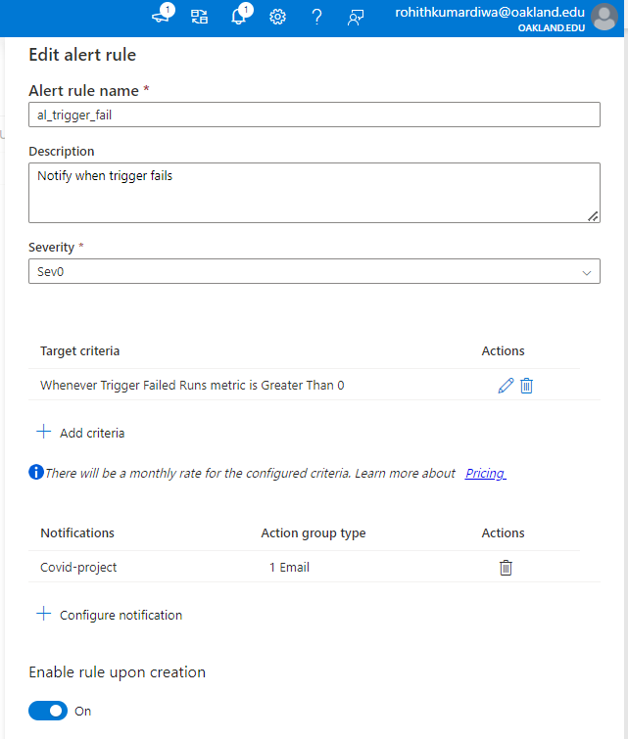

***Conclusion***

This project is a prototype for what can be implemented in the free tier version. In an organization with the availability of high-quality paid resources, we can implement this solution architecture at a much larger scale. With more clusters, the performance will increase greatly. We can also make this solution more applicable by implementing slowly changing dimensions. With the paid version, we can have better alert and monitoring mechanism.

***Lessons Learned***

* We made the ingestion process more efficient by creating one pipeline to ingest all the data rather than multiple pipelines for each csv file.
* We found out that there is a big difference between General Purpose SQL server and Basic SQL server. The Basic SQL Server is cheaper and therefore is the one that we primarily used.
* Keeping resources active for long time has also made us waste a lot of money. We learned that we should turn off the debug to save some money.
* During the ingestion process, we noticed that there was redundant data every time that the file was copied. Therefore, we added a delete statement that would delete the original file so that there would not be redundant data.
* We also learned how to create data analytics expressions (DAX) queries to answer our managerial questions in PowerBI.

***Citations***

Agarwal, U. A. (n.d.). *Azure Storage Accounts Overview & Steps to create*. Cloud Training Program. Retrieved April 20, 2022, from https://k21academy.com/microsoft-azure/az-303/azure-storage-account/

*Data Factory - Data Integration Service: Microsoft azure*. Data Factory - Data Integration Service | Microsoft Azure. (n.d.). Retrieved April 20, 2022, from https://azure.microsoft.com/en-us/services/data-factory/